

Laboratory Certificate

This is to certify that Smt./Sri PRAMODH YADAV M Reg No 20201ISE0053 has satisfactorily completed the course of Experiments in DATA HANDLING AND VISUALIZATION Prescribed by the PRESIDENCY UNIVERSITY in the Laboratory of this College in the year 2023 - 2024

|  |
| --- |
| Signature of the Lecturer in Charge |

DATE:……………….

### INDEX

|  |  |
| --- | --- |
| SI NO. | Name of the Experiment |
| 01 | Introduction to Numpy |
| 02 | Working to Pandas |
| 03 | Data Cleaning |
| 04 | Zscore Normalization |
| 05 | Outlier Detection with IQR |
| 06 | Matplotlib |
| 07 | Interacting with Web API |
| 08 | Colormaps |
| 09 | Heatmaps |
| 10 | Seaborn color pallette |
| 11 | Univariate, Bivariate, Multivariate Visualization |
| 12 | Text |
| 13 | Time Series |

### LABSHEET 1

from matplotlib import pyplot as plt

plt.style.use('seaborn-whitegrid')

import numpy as np print("step 1")

 step 1

<ipython-input-4-240c5389bdd3>:2: MatplotlibDeprecationWarning: The seaborn styles shipped by Matplotlib are deprecated since 3.6, plt.style.use('seaborn-whitegrid')

fig = plt.figure() ax = plt.axes()

ax.grid()

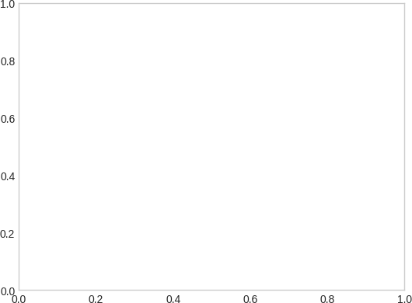

fig = plt.figure() ax = plt.axes()

x = np.linspace(0, 10, 1000) ax.plot(x, np.sin(x));

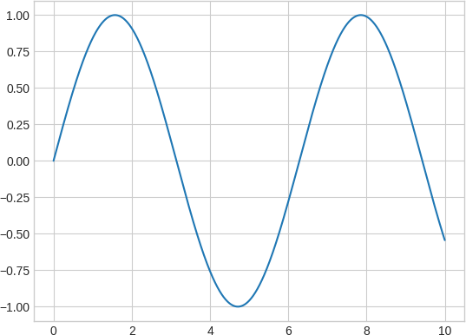

# Lets add a title and labels to the plot

fig = plt.figure() ax = plt.axes()

x = np.linspace(0, 10, 1000) ax.plot(x, np.sin(x))

ax.set_title('Simple Plot') # Add a title

ax.set_xlabel('x label') # Add x label ax.set_ylabel('y label'); # Add y label

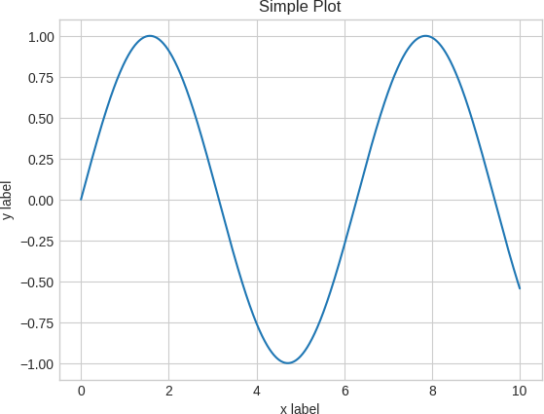

# Lets add a title to the plot above fig = plt.figure()

ax = plt.axes()

x = np.linspace(0, 10, 1000) ax.plot(x, np.sin(x))

ax.plot(x, np.cos(x))

#ax.plot(x, np.tan(x))

ax.set_title('Multiple Lines'); ax.set_xlabel('x label')

ax.set_ylabel('y label') plt.show()

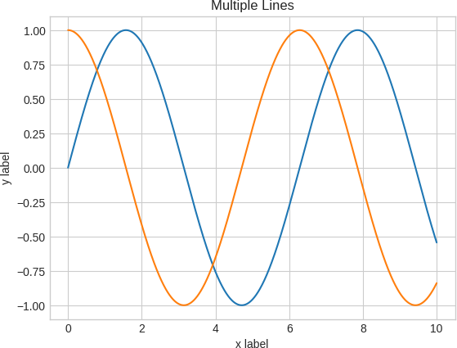

fig = plt.figure() ax = plt.axes()

x = np.linspace(0, 10, 1000)

ax.plot(x, np.sin(x), label = 'sin')

ax.plot(x, np.cos(x), label = 'cos') ax.set_title('Multiple Lines');

ax.set_xlabel('x label') ax.set_ylabel('y label') ax.legend()

# ax.legend(loc=1) plt.show()

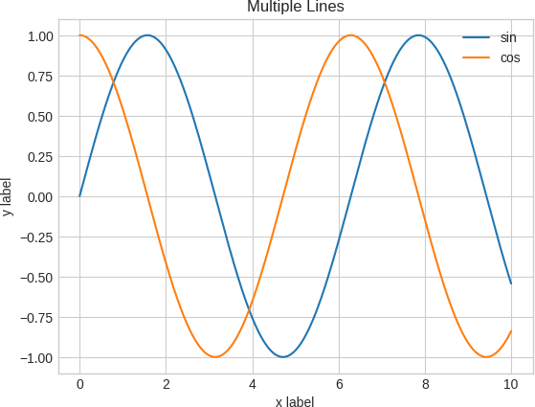

fig = plt.figure() ax = plt.axes()

x = np.linspace(0, 10, 1000)

ax.plot(x, np.sin(x), label = 'sin', color = 'red') # specify color by name

ax.plot(x, np.cos(x), label = 'cos', color = 'g') # short color code (rgbcmyk) ax.set_title('Multiple Lines');

ax.set_xlabel('x label') ax.set_ylabel('y label') ax.legend();

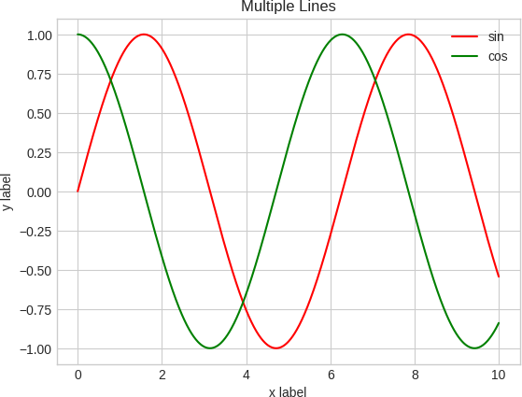

fig = plt.figure() ax = plt.axes()

# ax.grid(linestyle = '--')

x = np.linspace(0, 10, 1000)

ax.plot(x, np.sin(x), label = 'sin', linestyle = 'dashed') ax.plot(x, np.cos(x), label = 'cos', linestyle = 'dotted')

ax.plot(x, np.sin(x+1), label = 'cos', linestyle = 'dashdot') ax.set_title('Multiple Lines');

ax.set_xlabel('x label') ax.set_ylabel('y label') ax.legend();

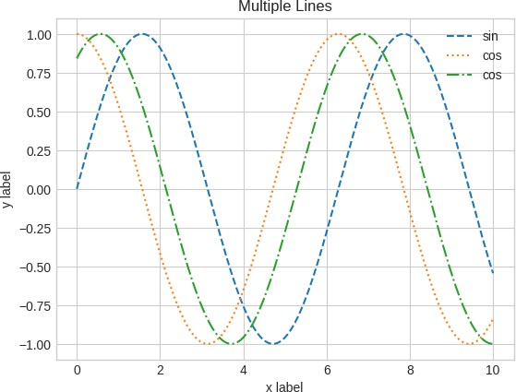

fig = plt.figure() ax = plt.axes()

x = np.linspace(0, 10, 1000) ax.plot(x, np.sin(x))

ax.set_xlim(-5, 15)

ax.set_ylim(-3, 3);

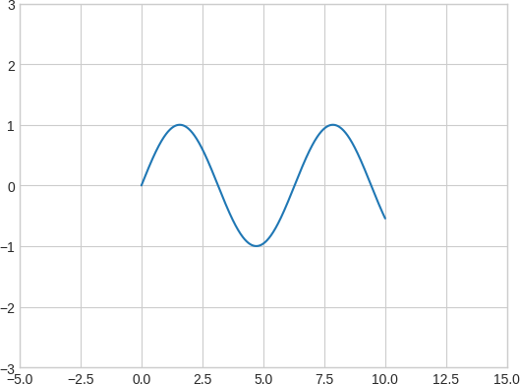

fig, ax = plt.subplots() # a figure with a single Axes



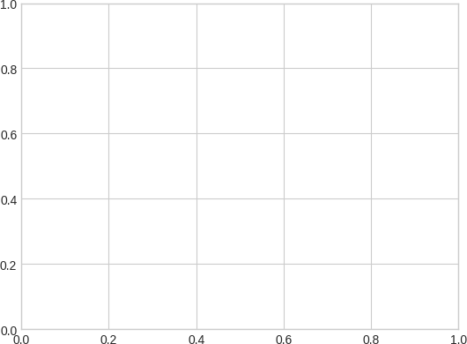fig, axs = plt.subplots(2, 2, figsize=(10,6)) # a figure with a 2x2 grid of Axes x = np.linspace(0, 10, 1000)

axs[0,0].plot(x, np.sin(x))

axs[0,1].plot(x, np.cos(x), color = 'maroon')

axs[1,0].plot(x, np.sin(x+2), color = 'blue')

axs[1,1].plot(x, np.sin(x+4), color = 'green');

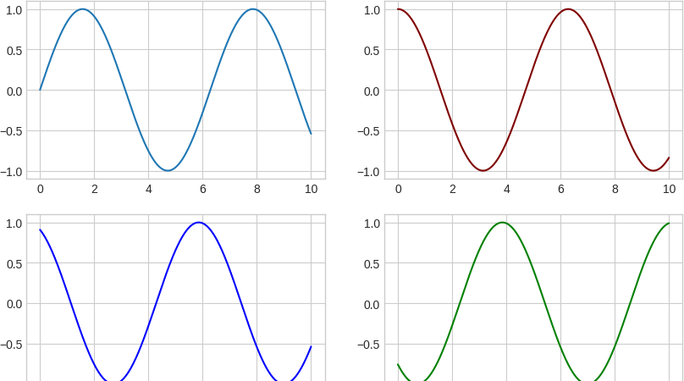

###  LABSHEET 2

 pandas

import pandas as pd

data=pd.read_csv(r'C:\Users\Thejas Venugopal\Downloads\nyc_weather.csv') data.head()

EST Temperature DewPoint Humidity Sea Level

**PressureIn**

VisibilityMiles WindSpeedMP

**0** 1/1/2016 38 23 52 30.03 10 8.

**1** 1/2/2016 36 18 46 30.02 10 7.

**2** 1/3/2016 40 21 47 29.86 10 8.

**3** 1/4/2016 25 9 44 30.05 10 9.

 pandas series

import numpy as np

d=np.array(['a','b','c','d']) s=pd.Series(d)

print(s)

 0 a

1. b
2. c
3. d

dtype: object

#####  with d being a dictionary

d={'a':1.,'b':2,'c':3}

s=pd.Series(d,index=['b','c','d']) s

 b 2.0

c 3.0

d NaN

dtype: float64

#####  changing the index

d=np.array(['a','b','c','d'])

s=pd.Series(d,index=[100,101,102,103]) print(s)



|  |  |
| --- | --- |
| 100 | a |
| 101 | b |
| 102 | c |
| 103 | d |

dtype: object

#####  dtype = float

n=np.array([1,2,3])

s1=pd.Series(n,dtype=float) s1



|  |  |
| --- | --- |
| 0 | 1.0 |
| 1 | 2.0 |
| 2 | 3.0 |

##### syntax

pd.Series(data,index=[ ],dtype=, name=, copy=,)

#####  combining 2 arrays to make an object

a1=np.array([1,2,3])

a2=np.array(['a','b','z']) s2=pd.Series(a1,a2)

s2



|  |  |
| --- | --- |
| a | 1 |
| b | 2 |
| z | 3 |

dtype: int32

#####  handling missing values

d={'a':1.,'b':2,'c':3}

s=pd.Series(d,index=['b','c','d']) print(s)

 b 2.0

c 3.0

d NaN

dtype: float64

s.isna().sum()

 1

s.dropna()

 b 2.0

c 3.0

dtype: float64

d={'a':1.,'b':2,'c':3}

s=pd.Series(d,index=['b','c','d']) print(s)

 b 2.0

c 3.0

d NaN

dtype: float64

s.fillna(2)

 b 2.0

c 3.0

d 2.0

dtype: float64

#####  accessing elements from the index

series=pd.Series([1,2,3,4,5],index=['a','b','c','d','e']) series[1]

 2

series[:3]

 a 1

b 2

c 3



series[['a','c','e']]

 a 1

c 3

e 5

dtype: int64

series1=pd.Series([103,1079,978],index=[' a hundred and three','one thousand seventy nine','nine hundred seventy eight']) series1['nine hundred seventy eight']

978

###  DATA FRAME

import pandas as pd

data = {'Name':['Alice', 'Bob', 'Claire', 'David'], 'Age':[20, 21, 20, 22]}

df = pd.DataFrame(data) print(df)

 Name Age

1. Alice 20
2. Bob 21
3. Claire 20
4. David 22

# creating a dataframe from a list of dictionary data = [{'Name': 'Alice', 'Age': 20},

{'Name': 'Bob', 'Age': 21},

{'Name': 'Claire', 'Age': 20},

{'Name': 'David', 'Age': 22}] df = pd.DataFrame(data)

print(df)

 Name Age

1. Alice 20
2. Bob 21
3. Claire 20
4. David 22

pd.DataFrame(df)

**Name Age**

* 1. Alice 20 
  2. Bob 21
  3. Claire 20
  4. David 22

Start coding or ge nerate with AI.

# LABSHEET 3

Data Cleaning and Data Preprocessing:

1. Data cleaning is the process of changing or eliminating garbage, incorrect, duplicate, corrupted, or incomplete data in a dataset.
2. There’s no such absolute way to describe the precise steps in the data cleaning process because the processes may vary from dataset to dataset.

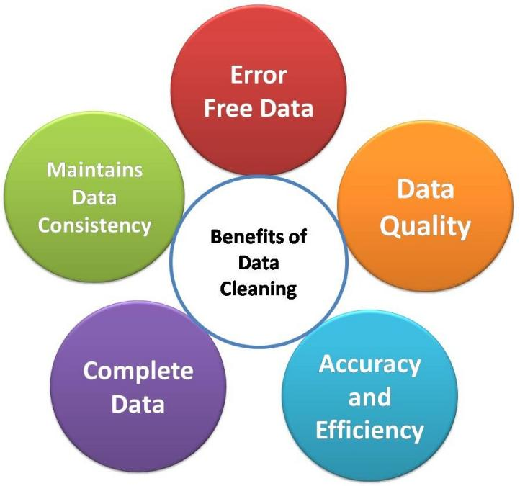

#  Data Cleaning Cycle

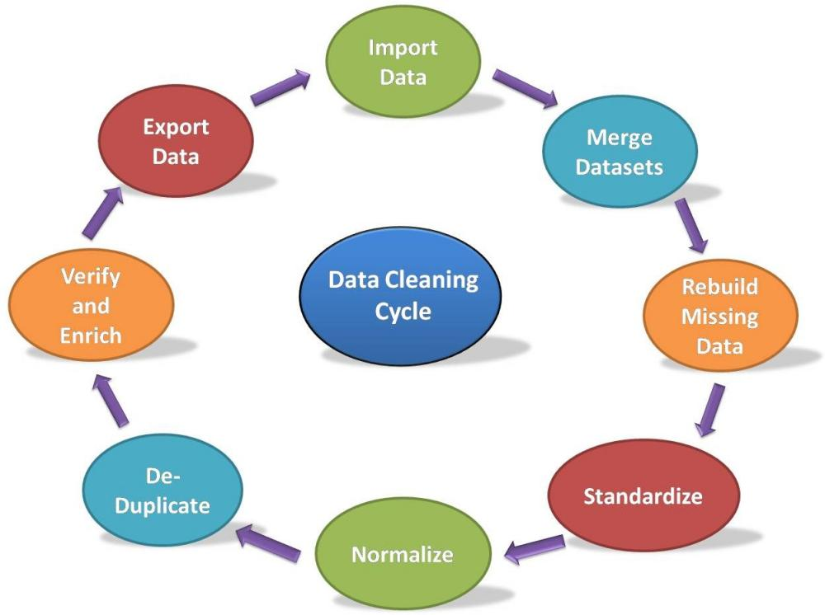

Missing Values:

# import the pandas library import pandas as pd

import numpy as np

df = pd.DataFrame(np.random.randn(5, 3), index=['a', 'c', 'e', 'f',

'h'],columns=['one', 'two', 'three']) print(df)

# df = df.reindex(['a', 'b', 'c', 'd', 'e', 'f', 'g', 'h']) # print (df)

 one two three

a 0.375319 -0.763927 -0.762393

c -1.093644 1.335944 -0.668966

e -0.013401 0.155461 -0.843651

f 0.423813 0.900266 -0.828664

h -0.644593 2.654895 1.211697

**Check for Missing Values:**

To make detecting missing values easier (and across different array dtypes),Pandas provides the

**isnull()** and **notnull()** functions, which are also methods on Series and DataFrame objects −

import pandas as pd import numpy as np

df = pd.DataFrame(np.random.randn(5, 3), index=['a', 'c', 'e', 'f',

'h'],columns=['one', 'two', 'three'])

df = df.reindex(['a', 'b', 'c', 'd', 'e', 'f', 'g', 'h']) # print (df['one'].isnull())

# print(df)

print(df["one"].isnull())

 a False

1. True
2. False
3. True
4. False
5. False
6. True
7. False

Name: one, dtype: bool

#### Replacing the Missing Values

#Replace the missing values by 0 import pandas as pd

import numpy as np

df = pd.DataFrame(np.random.randn(3, 3), index=['a', 'c', 'e'],columns=['one', 'two', 'three'])

df = df.reindex(['a', 'b', 'c']) print (df)

print ("NaN replaced with '0':") print (df.fillna(0))

 one two three a -0.961858 -1.671248 0.556286

b NaN NaN NaN c -0.386504 -0.709324 0.622838

NaN replaced with '0':

|  |  |  |
| --- | --- | --- |
| one | two | three |
| a -0.961858 | -1.671248 | 0.556286 |
| b 0.000000 | 0.000000 | 0.000000 |
| c -0.386504 | -0.709324 | 0.622838 |

#### Fill NA Forward and Backward

# Method Action

pad/fill Fill methods Forward bfill/backfill Fill methods Backward

import pandas as pd import numpy as np

df = pd.DataFrame(np.random.randn(5, 3), index=['a', 'c', 'e', 'f',

'h'],columns=['one', 'two', 'three'])

df = df.reindex(['a', 'b', 'c', 'd', 'e', 'f', 'g', 'h']) print(df)

print (df.fillna(method='pad'))

 one two three a 0.109813 -1.940379 -0.444834

b NaN NaN NaN c -0.208020 0.309864 0.819870

d NaN NaN NaN e -0.465764 0.215614 1.031519

f 1.189843 3.814140 0.954030

g NaN NaN NaN h 0.480653 0.552598 -0.888482

one two three a 0.109813 -1.940379 -0.444834

b 0.109813 -1.940379 -0.444834

c -0.208020 0.309864 0.819870

d -0.208020 0.309864 0.819870

e -0.465764 0.215614 1.031519

f 1.189843 3.814140 0.954030

g 1.189843 3.814140 0.954030

h 0.480653 0.552598 -0.888482

import pandas as pd import numpy as np

df = pd.DataFrame(np.random.randn(5, 3), index=['a', 'c', 'e', 'f',

'h'],columns=['one', 'two', 'three'])

df = df.reindex(['a', 'b', 'c', 'd', 'e', 'f', 'g', 'h']) print (df.fillna(method='bfill'))



|  |  |  |
| --- | --- | --- |
| one | two | three |
| a -1.204446 | 2.137228 | -0.388020 |
| b 1.327178 | 2.355456 | -1.347412 |
| c 1.327178 | 2.355456 | -1.347412 |
| d -0.228600 | 1.300295 | 0.939832 |
| e -0.228600 | 1.300295 | 0.939832 |
| f -0.938383 | 2.278881 | -0.098408 |
| g 0.726762 | 0.456629 | -1.167753 |
| h 0.726762 | 0.456629 | -1.167753 |

#### Drop Missing Values:

Use dropna function along with the axis argument.

By default, axis=0, i.e., along row, which means that if any value within a row is NA then the whole row is excluded.

import pandas as pd import numpy as np

df = pd.DataFrame(np.random.randn(5, 3), index=['a', 'c', 'e', 'f',

'h'],columns=['one', 'two', 'three']) print(df)

df = df.reindex(['a', 'b', 'c', 'd', 'e', 'f', 'g', 'h']) print(df)

print (df.dropna())

 one two three a -0.481989 -1.249458 -2.316982

c 1.119240 -1.054186 -0.972090

e -0.991040 -0.749165 0.259387

f -1.300768 -0.000567 -0.056870

h 0.497341 0.984014 -1.094049

one two three a -0.481989 -1.249458 -2.316982

b NaN NaN NaN

c 1.119240 -1.054186 -0.972090

d NaN NaN NaN e -0.991040 -0.749165 0.259387

f -1.300768 -0.000567 -0.056870

g NaN NaN NaN h 0.497341 0.984014 -1.094049

one two three a -0.481989 -1.249458 -2.316982

c 1.119240 -1.054186 -0.972090

e -0.991040 -0.749165 0.259387

f -1.300768 -0.000567 -0.056870

h 0.497341 0.984014 -1.094049

#### Replace Missing (or) Generic Values:

We can achieve this by applying the **replace** method.

Replacing NA with a scalar value is equivalent behavior of the **fillna()** function.

import pandas as pd import numpy as np

df = pd.DataFrame({'one':[10,20,30,40,50,2000],

'two':[1000,0,30,40,50,60]})

print(df)

print (df.replace({1000:10,2000:60}))

 one two

0 10 1000

1 20 0

2 30 30

3 40 40

4 50 50

5 2000 60

one two

0 10 10

1 20 0

4 50 50

5 60 60

#  Data Preprocessing

1. Load data in Pandas
2. Drop columns that aren’t useful
3. Drop rows with missing values
4. Create dummy variables
5. Take care of missing data
6. Convert the data frame to NumPy

**Download Titanic-Dataset from Kaggle.com.**

**Here we are going to use train.csv dataset for preprocessing.**

import pandas as pd import numpy as np

from google.colab import drive drive.mount('/content/drive')

Mounted at /content/drive

df = pd.read_csv(r"C:\Users\Thejas Venugopal\Downloads\train (1).csv") df.info()

 <class 'pandas.core.frame.DataFrame'> RangeIndex: 891 entries, 0 to 890

Data columns (total 12 columns):

# Column Non-Null Count Dtype

|  |  |  |  |  |  |  |
| --- | --- | --- | --- | --- | --- | --- |
| 0 |  | PassengerId | 891 | non-null |  | int64 |
| 1 |  | Survived | 891 | non-null |  | int64 |
| 2 |  | Pclass | 891 | non-null |  | int64 |
| 3 |  | Name | 891 | non-null |  | object |
| 4 |  | Sex | 891 | non-null |  | object |
| 5 |  | Age | 714 | non-null |  | float64 |
| 6 |  | SibSp | 891 | non-null |  | int64 |
| 7 |  | Parch | 891 | non-null |  | int64 |
| 8 |  | Ticket | 891 | non-null |  | object |
| 9 |  | Fare | 891 | non-null |  | float64 |
| 10 |  | Cabin | 204 | non-null |  | object |
| 11 |  | Embarked | 889 | non-null |  | object |

dtypes: float64(2), int64(5), object(5) memory usage: 83.7+ KB

cols=['Name','Ticket','Cabin'] df=df.drop(cols,axis=0)

df.info()



KeyError Traceback (most recent call last)

C:\Users\THEJAS~1\AppData\Local\Temp/ipykernel_20436/1019933480.py in <module>

1 cols=['Name','Ticket','Cabin']

----> 2 df=df.drop(cols)

3 df.info()

c:\Users\Thejas Venugopal\anaconda3\lib\site-packages\pandas\util\_decorators.py in wrapper(*args, **kwargs)

309 stacklevel=stacklevel,

310 )

--> 311 return func(*args, **kwargs) 312

313 return wrapper

c:\Users\Thejas Venugopal\anaconda3\lib\site-packages\pandas\core\frame.py in drop(self, labels, axis, index, columns, level, inplace, errors)

|  |  |  |
| --- | --- | --- |
| 4904 | weight 1.0 | 0.8 |
| 4905 | """ |  |
| -> 4906  4907 | return super().drop( labels=labels, |  |
| 4908 | axis=axis, |  |

c:\Users\Thejas Venugopal\anaconda3\lib\site-packages\pandas\core\generic.py in drop(self, labels, axis, index, columns, level, inplace, errors)

4148 for axis, labels in axes.items():

4149 if labels is not None:

-> 4150 obj = obj._drop_axis(labels, axis, level=level, errors=errors)

4151

4152 if inplace:

c:\Users\Thejas Venugopal\anaconda3\lib\site-packages\pandas\core\generic.py in

_drop_axis(self, labels, axis, level, errors)

4183 new_axis = axis.drop(labels, level=level, errors=errors) 4184 else:

-> 4185 new_axis = axis.drop(labels, errors=errors)

4186 result = self.reindex(**{axis_name: new_axis}) 4187

c:\Users\Thejas Venugopal\anaconda3\lib\site-packages\pandas\core\indexes\base.py in drop(self, labels, errors)

6015 if mask.any():

6016 if errors != "ignore":

-> 6017 raise KeyError(f"{labels[mask]} not found in axis")

#### Drop the rows having no values

df = df.dropna() df.info()

 <class 'pandas.core.frame.DataFrame'>

# Column Non-Null Count Dtype

|  |  |  |  |  |  |  |
| --- | --- | --- | --- | --- | --- | --- |
| 0 |  | PassengerId | 712 | non-null |  | int64 |
| 1 |  | Survived | 712 | non-null |  | int64 |
| 2 |  | Pclass | 712 | non-null |  | int64 |
| 3 |  | Sex | 712 | non-null |  | object |
| 4 |  | Age | 712 | non-null |  | float64 |
| 5 |  | SibSp | 712 | non-null |  | int64 |
| 6 |  | Parch | 712 | non-null |  | int64 |
| 7 |  | Fare | 712 | non-null |  | float64 |
| 8 |  | Embarked | 712 | non-null |  | object |

dtypes: float64(2), int64(5), object(2) memory usage: 55.6+ KB

#### Creating Dummy variables

Instead of wasting our data, let’s convert the Pclass, Sex and Embarked to columns in Pandas and drop them after conversion.

dummies = []

cols = ['Pclass', 'Sex', 'Embarked'] for col in cols:

dummies.append(pd.get_dummies(df[col]))

Transfor the eigth columns

titanic_dummies = pd.concat(dummies, axis=1)

Concatenate the values with data frame

df = pd.concat((df,titanic_dummies), axis=1)

Remove the unwanted cols

df = df.drop(['Pclass', 'Sex', 'Embarked'], axis=1)

#### Take care of Missing data

Let’s compute a **median or interpolate()** all the ages and fill those missing age values. Pandas has an interpolate() function that will replace all the missing NaNs to interpolated values.

# Min Max Scaler and Standardization

**Normalization** is a rescaling of the data from the original range so that all values are within the new range of 0 and 1.

A value is normalized as follows: y = (x – min) / (max – min)

from sklearn.preprocessing import MinMaxScaler data = [[-1, 2], [-0.5, 6], [0, 10], [1, 18]]

scaler = MinMaxScaler() print(scaler.fit(data)) MinMaxScaler()

print(scaler.data_max_)

print(scaler.transform(data))

 MinMaxScaler() [ 1. 18.]

|  |  |
| --- | --- |
| [[0. | 0. ] |
| [0.25 | 0.25] |
| [0.5 | 0.5 ] |
| [1. | 1. ]] |

#  Data Standardization

**Standardizing** a dataset involves rescaling the distribution of values so that the mean of observed values is 0 and the standard deviation is 1.

A value is standardized as follows:

y = (x – mean) / standard_deviation Where the mean is calculated as:

mean = sum(x) / count(x)

And the standard_deviation is calculated as: standard_deviation = sqrt( sum( (x – mean)^2 ) / count(x))

from numpy import asarray

from sklearn.preprocessing import StandardScaler # define data

data = asarray([[100, 0.001], [8, 0.05],

[50, 0.005],

[88, 0.07],

[4, 0.1]])

print(data)

# define standard scaler scaler = StandardScaler() # transform data

scaled = scaler.fit transform(data)

 LABSHEET 4

import numpy as np

import pandas as pd

# Example dataset data = {

'Feature1': [10, 20, 30, 40, 50],

'Feature2': [5, 15, 25, 35, 45]

}

# Create a DataFrame

df = pd.DataFrame(data)

# Display the original data print("Original Data:")

print(df)

 Original Data:

Feature1 Feature2 0 10 5

1 20 15

2 30 25

3 40 35

4 50 45

# Function to normalize data using Z-score def zscore_normalization(df):

normalized_df = df.copy()

for column in normalized_df.columns:

mean = normalized_df[column].mean() std = normalized_df[column].std()

normalized_df[column] = (normalized_df[column] - mean) / std return normalized_df

# Normalize the DataFrame

normalized_df = zscore_normalization(df)

# Display the normalized data

print("\nNormalized Data (Z-score):") print(normalized_df)



Normalized Data (Z-score): Feature1 Feature2

0 -1.264911 -1.264911

1 -0.632456 -0.632456

2 0.000000 0.000000

3 0.632456 0.632456

4 1.264911 1.264911

###  LABSHEET 5

from google.colab import files df = files.upload()

 No file chosen Upload widget is only available when the cell has been executed in the current browser session. Please rerun this cell to enable.

Choose Files

Saving train.csv to train.csv

import pandas as pd import numpy as np

data = pd.read_csv('./train.csv') data.head()



|  |  |  |  |  |  |  |  |  |  |  |  |  |
| --- | --- | --- | --- | --- | --- | --- | --- | --- | --- | --- | --- | --- |
| **PassengerId** | | **Survived** | **Pclass** | **Name** | **Sex** | **Age** | **SibSp** | **Parch** | **Ticket** | **Fare** | **Cabin** | **Embarked** |
| **0** 493 | | 0 | 1 | Molson, Mr. Harry Markland | male | 55.0 | 0 | 0 | 113787 | 30.5000 | C30 | S |
| **1** | 53 | 1 | 1 | Harper, Mrs. Henry Sleeper (Myna  Haxtun) | female | 49.0 | 1 | 0 | PC 17572 | 76.7292 | D33 | C |
| **2** | 388 | 1 | 2 | Buss, Miss. Kate | female | 36.0 | 0 | 0 | 27849 | 13.0000 | NaN | S |
| **3** | 192 | 0 | 2 | Carbines, Mr. William | male | 19.0 | 0 | 0 | 28424 | 13.0000 | NaN | S |
| **4** | 687 | 0 | 3 | Panula, Mr. Jaako Arnold | male | 14.0 | 4 | 1 | 3101295 | 39.6875 | NaN | S |

cols = ['Name', 'Ticket', 'Cabin']

filtered_data = data.drop(cols, axis = 1) filtered_data.info()

 <class 'pandas.core.frame.DataFrame'> RangeIndex: 712 entries, 0 to 711

Data columns (total 9 columns):

|  |  |  |  |  |  |
| --- | --- | --- | --- | --- | --- |
| # |  | Column | Non-Null Count |  | Dtype |
| 0 |  | PassengerId | 712 non-null |  | int64 |
| 1 |  | Survived | 712 non-null |  | int64 |
| 2 |  | Pclass | 712 non-null |  | int64 |
| 3 |  | Sex | 712 non-null |  | object |
| 4 |  | Age | 566 non-null |  | float64 |
| 5 |  | SibSp | 712 non-null |  | int64 |
| 6 |  | Parch | 712 non-null |  | int64 |
| 7 |  | Fare | 712 non-null |  | float64 |
| 8 |  | Embarked | 710 non-null |  | object |

dtypes: float64(2), int64(5), object(2) memory usage: 50.2+ KB

data = data.dropna() data.info()

 <class 'pandas.core.frame.DataFrame'> Int64Index: 148 entries, 0 to 695

Data columns (total 12 columns):

|  |  |  |  |  |  |
| --- | --- | --- | --- | --- | --- |
| # |  | Column | Non-Null Count |  | Dtype |
| 0 |  | PassengerId | 148 non-null |  | int64 |
| 1 |  | Survived | 148 non-null |  | int64 |
| 2 |  | Pclass | 148 non-null |  | int64 |
| 3 |  | Name | 148 non-null |  | object |
| 4 |  | Sex | 148 non-null |  | object |
| 5 |  | Age | 148 non-null |  | float64 |
| 6 |  | SibSp | 148 non-null |  | int64 |
| 7 |  | Parch | 148 non-null |  | int64 |
| 8 |  | Ticket | 148 non-null |  | object |
| 9 |  | Fare | 148 non-null |  | float64 |
| 10 |  | Cabin | 148 non-null |  | object |
| 11 |  | Embarked | 148 non-null |  | object |

dtypes: float64(2), int64(5), object(5) memory usage: 15.0+ KB

data.head()



|  |  |  |  |  |  |  |  |  |  |  |  |  |
| --- | --- | --- | --- | --- | --- | --- | --- | --- | --- | --- | --- | --- |
|  | **PassengerId** | **Survived** | **Pclass** | **Name** | **Sex** | **Age** | **SibSp** | **Parch** | **Ticket** | **Fare** | **Cabin** | **Embarked** |
| **0** | 493 | 0 | 1 | Molson, Mr. Harry Markland | male | 55.0 | 0 | 0 | 113787 | 30.5000 | C30 | S |

PC 17572

|  |  |  |
| --- | --- | --- |
| 76.7292 | D33 | C |
| 12.4750 | E121 | S |
| 71.0000 | B22 | S |

|  |  |  |  |  |  |  |  |  |
| --- | --- | --- | --- | --- | --- | --- | --- | --- |
| **1** | 53 | 1 | 1 | Harper, Mrs. Henry Sleeper (Myna | female | 49.0 | 1 | 0 |
|  |  |  |  | Haxtun) |  |  |  |  |
| **9** | 752 | 1 | 3 | Moor, Master. Meier | male | 6.0 | 0 | 1 |
| **10** | 541 | 1 | 1 | Crosby, Miss. Harriet R | female | 36.0 | 0 | 2 |

392096

WE/P 5735

dummies = []

cols = ['Pclass', 'Sex', 'Embarked'] for col in cols:

dummies.append(pd.get_dummies(data[col]))

|  |  |  |  |
| --- | --- | --- | --- |
| dummies |  | | |
| [ | 1 | 2 | 3 |
| 0 | 1 | 0 | 0 |
| 1 | 1 | 0 | 0 |
| 2 | 0 | 1 | 0 |
| 3 | 0 | 1 | 0 |
| 4 | 0 | 0 | 1 |

.. .. .. .. 707 0 0 1

708 1 0 0

709 0 0 1

710 0 1 0

711 1 0 0

[712 rows x 3 columns],

|  |  |  |
| --- | --- | --- |
| 0 | female  0 | male  1 |
| 1 | 1 | 0 |
| 2 | 1 | 0 |
| 3 | 0 | 1 |
| 4 | 0 | 1 |
| .. | ... | ... |
| 707 | 1 | 0 |
| 708 | 0 | 1 |
| 709 | 0 | 1 |
| 710 | 0 | 1 |
| 711 | 0 | 1 |

[712 rows x 2 columns],

|  |  |  |  |
| --- | --- | --- | --- |
| 0 | C  0 | Q  0 | S  1 |
| 1 | 1 | 0 | 0 |
| 2 | 0 | 0 | 1 |
| 3 | 0 | 0 | 1 |
| 4 | 0 | 0 | 1 |

.. .. .. .. 707 1 0 0

708 1 0 0

709 0 0 1

710 0 0 1

711 0 0 1

[712 rows x 3 columns]]

titanic_dummies = pd.concat(dummies, axis = 1) titanic_dummies



|  |  |  |  |  |  |  |  |  |
| --- | --- | --- | --- | --- | --- | --- | --- | --- |
|  | **1** | **2** | **3** | **female** | **male** | **C** | **Q** | **S** |
| **0** | 1 | 0 | 0 | 0 | 1 | 0 | 0 | 1 |
| **1** | 1 | 0 | 0 | 1 | 0 | 1 | 0 | 0 |
| **2** | 0 | 1 | 0 | 1 | 0 | 0 | 0 | 1 |
| **3** | 0 | 1 | 0 | 0 | 1 | 0 | 0 | 1 |
| **4** | 0 | 0 | 1 | 0 | 1 | 0 | 0 | 1 |
| **...** | ... | ... | ... | ... | ... | ... | ... | ... |
| **707** | 0 | 0 | 1 | 1 | 0 | 1 | 0 | 0 |
| **708** | 1 | 0 | 0 | 0 | 1 | 1 | 0 | 0 |
| **709** | 0 | 0 | 1 | 0 | 1 | 0 | 0 | 1 |
| **710** | 0 | 1 | 0 | 0 | 1 | 0 | 0 | 1 |
| **711** | 1 | 0 | 0 | 0 | 1 | 0 | 0 | 1 |

712 rows × 8 columns

data.drop(['Pclass', 'Sex', 'Embarked'], axis = 1)



|  |  |  |  |  |  |  |  |  |  |
| --- | --- | --- | --- | --- | --- | --- | --- | --- | --- |
|  | **PassengerId** | **Survived** | **Name** | **Age** | **SibSp** | **Parch** | **Ticket** | **Fare** | **Cabin** |
| **0** | 493 | 0 | Molson, Mr. Harry Markland | 55.0 | 0 | 0 | 113787 | 30.5000 | C30 |
| **1** | 53 | 1 | Harper, Mrs. Henry Sleeper (Myna Haxtun) | 49.0 | 1 | 0 | PC 17572 | 76.7292 | D33 |
| **2** | 388 | 1 | Buss, Miss. Kate | 36.0 | 0 | 0 | 27849 | 13.0000 | NaN |
| **3** | 192 | 0 | Carbines, Mr. William | 19.0 | 0 | 0 | 28424 | 13.0000 | NaN |
| **4** | 687 | 0 | Panula, Mr. Jaako Arnold | 14.0 | 4 | 1 | 3101295 | 39.6875 | NaN |
| **...** | ... | ... | ... | ... | ... | ... | ... | ... | ... |
| **707** | 859 | 1 | Baclini, Mrs. Solomon (Latifa Qurban) | 24.0 | 0 | 3 | 2666 | 19.2583 | NaN |
| **708** | 65 | 0 | Stewart, Mr. Albert A | NaN | 0 | 0 | PC 17605 | 27.7208 | NaN |
| **709** | 130 | 0 | Ekstrom, Mr. Johan | 45.0 | 0 | 0 | 347061 | 6.9750 | NaN |
| **710** | 21 | 0 | Fynney, Mr. Joseph J | 35.0 | 0 | 0 | 239865 | 26.0000 | NaN |
| **711** | 476 | 0 | Clifford, Mr. George Quincy | NaN | 0 | 0 | 110465 | 52.0000 | A14 |

712 rows × 9 columns

data['Age'] = data['Age'].interpolate() print(data)



|  |  |  |  |  |  |
| --- | --- | --- | --- | --- | --- |
| 0 | PassengerId  493 | Survived  0 | Pclass  1 | Name  Molson, Mr. Harry Markland | \ |
| 1 | 53 | 1 | 1 | Harper, Mrs. Henry Sleeper (Myna Haxtun) |  |
| 2 | 388 | 1 | 2 | Buss, Miss. Kate |  |
| 3 | 192 | 0 | 2 | Carbines, Mr. William |  |
| 4  .. | 687  ... | 0  ... | 3  ... | Panula, Mr. Jaako Arnold  ... |  |
| 707 | 859 | 1 | 3 | Baclini, Mrs. Solomon (Latifa Qurban) |  |
| 708 | 65 | 0 | 1 | Stewart, Mr. Albert A |  |
| 709 | 130 | 0 | 3 | Ekstrom, Mr. Johan |  |
| 710 | 21 | 0 | 2 | Fynney, Mr. Joseph J |  |
| 711 | 476 | 0 | 1 | Clifford, Mr. George Quincy |  |

Sex Age SibSp Parch Ticket Fare Cabin Embarked

|  |  |  |  |  |  |  |  |  |
| --- | --- | --- | --- | --- | --- | --- | --- | --- |
| 0 | male | 55.0 | 0 | 0 | 113787 | 30.5000 | C30 | S |
| 1 | female | 49.0 | 1 | 0 | PC 17572 | 76.7292 | D33 | C |
| 2 | female | 36.0 | 0 | 0 | 27849 | 13.0000 | NaN | S |
| 3 | male | 19.0 | 0 | 0 | 28424 | 13.0000 | NaN | S |
| 4 | male | 14.0 | 4 | 1 | 3101295 | 39.6875 | NaN | S |
| .. | ... | ... | ... | ... | ... | ... | ... | ... |
| 707 | female | 24.0 | 0 | 3 | 2666 | 19.2583 | NaN | C |
| 708 | male | 34.5 | 0 | 0 | PC 17605 | 27.7208 | NaN | C |
| 709 | male | 45.0 | 0 | 0 | 347061 | 6.9750 | NaN | S |
| 710 | male | 35.0 | 0 | 0 | 239865 | 26.0000 | NaN | S |
| 711 | male | 35.0 | 0 | 0 | 110465 | 52.0000 | A14 | S |

[712 rows x 12 columns]

from sklearn.preprocessing import MinMaxScaler data = [[-1, 1], [-0.5, 6], [0, 10], [1, 10]]

scaler = MinMaxScaler() print(scaler.fit(data)) print(scaler.data_max_)

print(scaler.transform(data))

 MinMaxScaler() [ 1. 10.]

[[0. 0. ]

[0.25 0.55555556]

|  |  |  |
| --- | --- | --- |
| [0.5 | 1. | ] |
| [1. | 1. | ]] |

###  LABSHEET 6

import matplotlib.pyplot as plt

# import seaborn as sn

# print a empty figure

# linespace 10 points with 1000 data points # styles

# sin x and cos x

# legend values, colors, setting x, y title and other stuff # line styles (different styles for each line)

# setting access limits (interval limits) # subplot (printing multiple plots)

# 0 1 y = sin and then 0 1 x = sin

 Code

Text

# print a empty figure fig = plt.figure()

plt.show()

 <Figure size 640x480 with 0 Axes>

# print sin wave until 4pi import numpy as np

x = np.linspace(0, 4*np.pi, 1000) y = np.sin(x)

z = np.cos(x) a = np.tan(x)

plt.plot(x, y, color="green", linestyle="dotted") plt.plot(x, z, color="blue")

# Set the x-axis and y-axis limits plt.xlim(0, 4*np.pi)

plt.ylim(-1, 1)

# Set the x-axis and y-axis labels plt.xlabel('x')

plt.ylabel('sin(x) and cos(x)')

# Show the plot # plt.show()

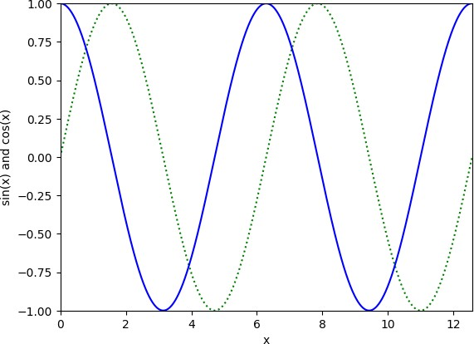 Text(0, 0.5, 'sin(x) and cos(x)')

plt.xlabel('empty grid')

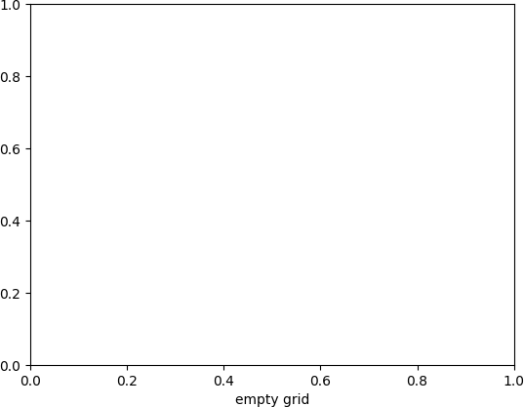Text(0.5, 0, 'empty grid')

x = np.linspace(0, 10, 1000)

y = np.linspace(0, 5, 1000)

# plt.plot(np.sin(x), np.cos(y)) plt.plot(x, y)

# Set the x-axis and y-axis limits plt.xlim(0, 10)

plt.ylim(0, 10)

# Set the x-axis and y-axis labels plt.xlabel('x')

plt.ylabel('y')

# Show the plot plt.show()

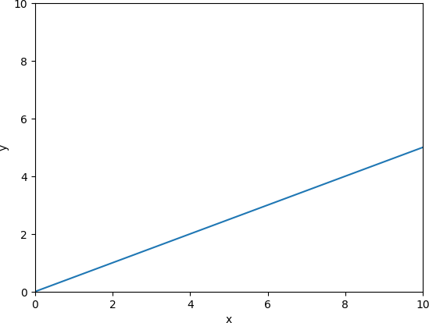

# printing a subplot

x = np.array([0, 1, 2, 3])

y = np.array([3, 8, 1, 10])

plt.subplot(2, 1, 1) plt.plot(x,y)

#plot 2:

#x = np.array([0, 1, 2, 3])

#y = np.array([10, 20, 30, 40])

#plt.subplot(2, 1, 2) #plt.plot(x,y)

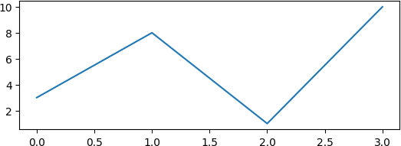[<matplotlib.lines.Line2D at 0x7a4d87f00ca0>]

# barchar example with dictionary import matplotlib.pyplot as plt

# Define the data

data = {'apples': 10, 'oranges': 15, 'bananas': 5, 'cherries': 20}

# Create a bar chart

plt.bar(list(data.keys()), list(data.values()), width=0.35, color="teal")

# Add title and axis labels plt.title('Fruit Sales')

plt.xlabel('Fruit') plt.ylabel('Sales')

# Show the plot plt.show()

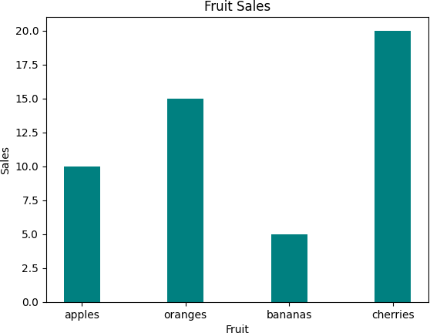

# example of horizontal barchart with dictionary # Define the data

data = {'apples': 10, 'oranges': 15, 'bananas': 5, 'cherries': 20}

# Create a horizontal bar chart

plt.barh(list(data.keys()), list(data.values()), color="purple", height=0.3)

# Add title and axis labels plt.title('Fruit Sales')

# plt.xlabel('Sales') # plt.ylabel('Fruit')

# Show the plot

show_plot = plt.show()

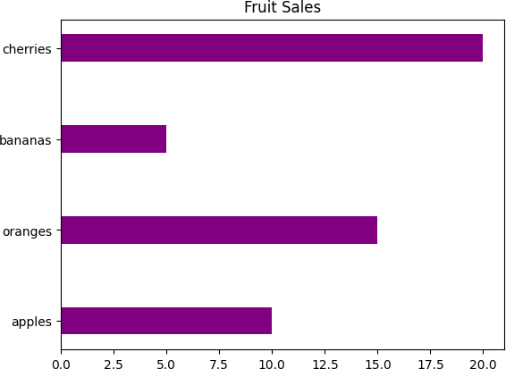AttributeError Traceback (most recent call last)

<ipython-input-56-dbd46437747f> in <cell line: 16>()

1. # Show the plot
2. show_plot = plt.show()

---> 16 show_plot.set_xlabel('something')

AttributeError: 'NoneType' object has no attribute 'set_xlabel'

fig, ax = plt.subplots()

# Example data

people = ('Tom', 'Thejas', 'Harry', 'Slim', 'Jim') y_pos = np.arange(len(people))

performance = 3 + 10 * np.random.rand(len(people)) error = np.random.rand(len(people))

hbars = ax.barh(y_pos, performance, xerr=error, align='center') ax.invert_yaxis()

ax.set_xlabel('Performance')

ax.set_title('How fast do you want to go today?')

# Label with given captions, custom padding and annotate options ax.bar_label(hbars, padding=8, color='b')

ax.set_xlim(right=15) plt.show()

 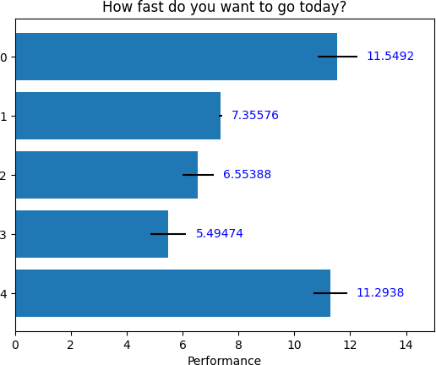

print(np.arange(10, 20, 2))

[10 12 14 16 18]

# pprint a axis plot with ax.grid() import matplotlib.pyplot as plt

# Create a figure and an axes object ax = plt.subplot()

# Plot some data

ax.plot([1, 2, 3, 4, 5], [5,6,7,8,9])

# Enable the grid ax.grid(True)

# Show the plot plt.show()

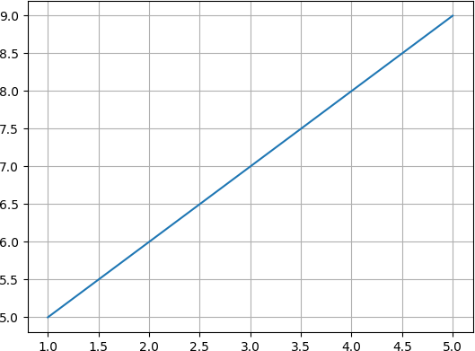

print(np.arange(10, 20, 2))

 [10 12 14 16 18]

# grouped bar charts example import numpy as np

import matplotlib.pyplot as plt

labels = ['G1', 'G2', 'G3', 'G4', 'G5']

men_means = [20, 34, 30, 35, 27]

women_means = [25, 32, 34, 20, 25]

x = np.arange(len(labels))

# width of the individual component width = 0.25

fig, ax = plt.subplots()

rects1 = ax.bar(x - width/2, men_means, width, label='Men')

rects2 = ax.bar(x + width/2, women_means, width, label='Women')

# Add some text for labels, title and custom x-axis tick labels, etc. ax.set_ylabel('Scores')

ax.set_title('Scores by group and gender') ax.set_xticks(x)

ax.set_xticklabels(labels) ax.legend();

plt.show()

 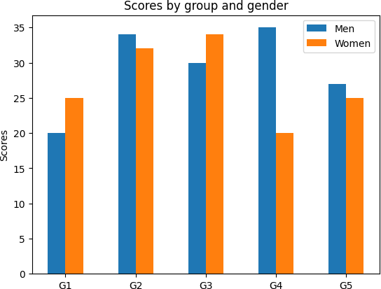

# adding labels to individual bars with their scores fig, ax = plt.subplots()

ax.grid(linestyle='--', color='0.75', axis = 'y')

ax.set_axisbelow(True)

rects1 = ax.bar(x - width/2, men_means, width, label='Men')

rects2 = ax.bar(x + width/2, women_means, width, label='Women')

ax.set_ylabel('Scores')

ax.set_title('Scores by group and gender') ax.set_xticks(x)

ax.set_xticklabels(labels) ax.legend()

# Adding the bar labels

ax.bar_label(rects1, padding=3) ax.bar_label(rects2, padding=3)

ax.set_ylim(0,40);

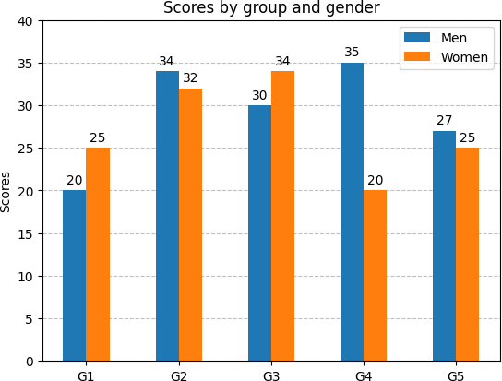

fig, ax = plt.subplots()

ax.grid(linestyle='--', color='0.75', axis = 'y');

ax.set_axisbelow(True) # set this to true for enabling gridlines p1 = ax.bar(labels, men_means, width, label='Men')

p2 = ax.bar(labels, women_means, width, bottom=men_means, label='Women')

ax.set_ylabel('Scores')

ax.set_title('Scores by group and gender') ax.legend()

# Label with label_type 'center'

ax.bar_label(p1, label_type='center') ax.bar_label(p2, label_type='center') ax.bar_label(p2)

ax.set_ylim(0,70)

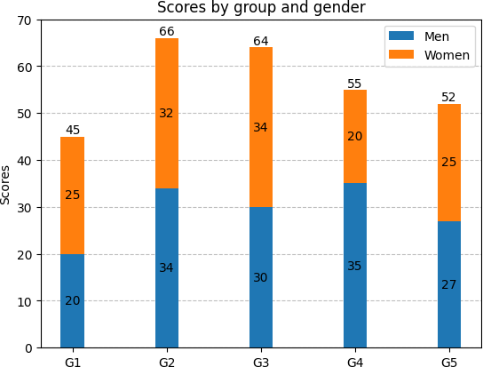 (0.0, 70.0)

# scatter plot

x = np.random.randn(20) y = np.random.randn(20)

fig, ax = plt.subplots() ax.grid(True)

ax.scatter(x, y, marker = 'h') # can change to any marker

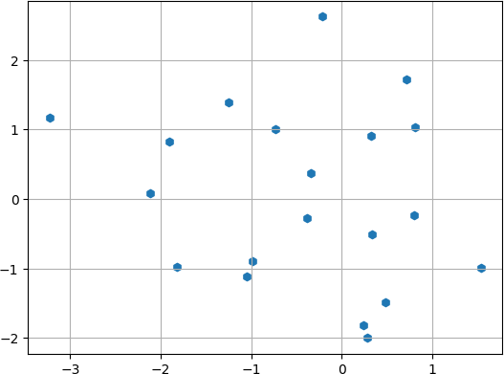<matplotlib.collections.PathCollection at 0x7b29651475e0>

fig, axs = plt.subplots(2, 3, sharex=True, sharey=True, figsize=(16,12)); # plt.style.use('seaborn-darkgrid')

# marker symbol

axs[0, 0].scatter(x, y, s=80, marker=">") axs[0, 0].set_title("marker='>'")

# marker from TeX

axs[0, 1].scatter(x, y, s=80, marker=r'$\alpha$') axs[0, 1].set_title("marker = " + r'$\alpha$')

# axs[0, 1].set_title(f"marker = {r'$\alpha$'}")

# marker from path

verts = [[-1, -1], [1, -1], [1, 1], [-1, -1]]

axs[0, 2].scatter(x, y, s=80, marker=verts) axs[0, 2].set_title("marker=verts")

axs[1, 0].scatter(x, y, s=80, marker=(5, 0))

axs[1, 0].set_title("marker=(5, 0)")

# regular star marker

axs[1, 1].scatter(x, y, s=80, marker=(5, 1))

axs[1, 1].set_title("marker=(5, 1)")

# regular asterisk marker

axs[1, 2].scatter(x, y, s=80, marker=(5, 2))

axs[1, 2].set_title("marker=(5, 2)");

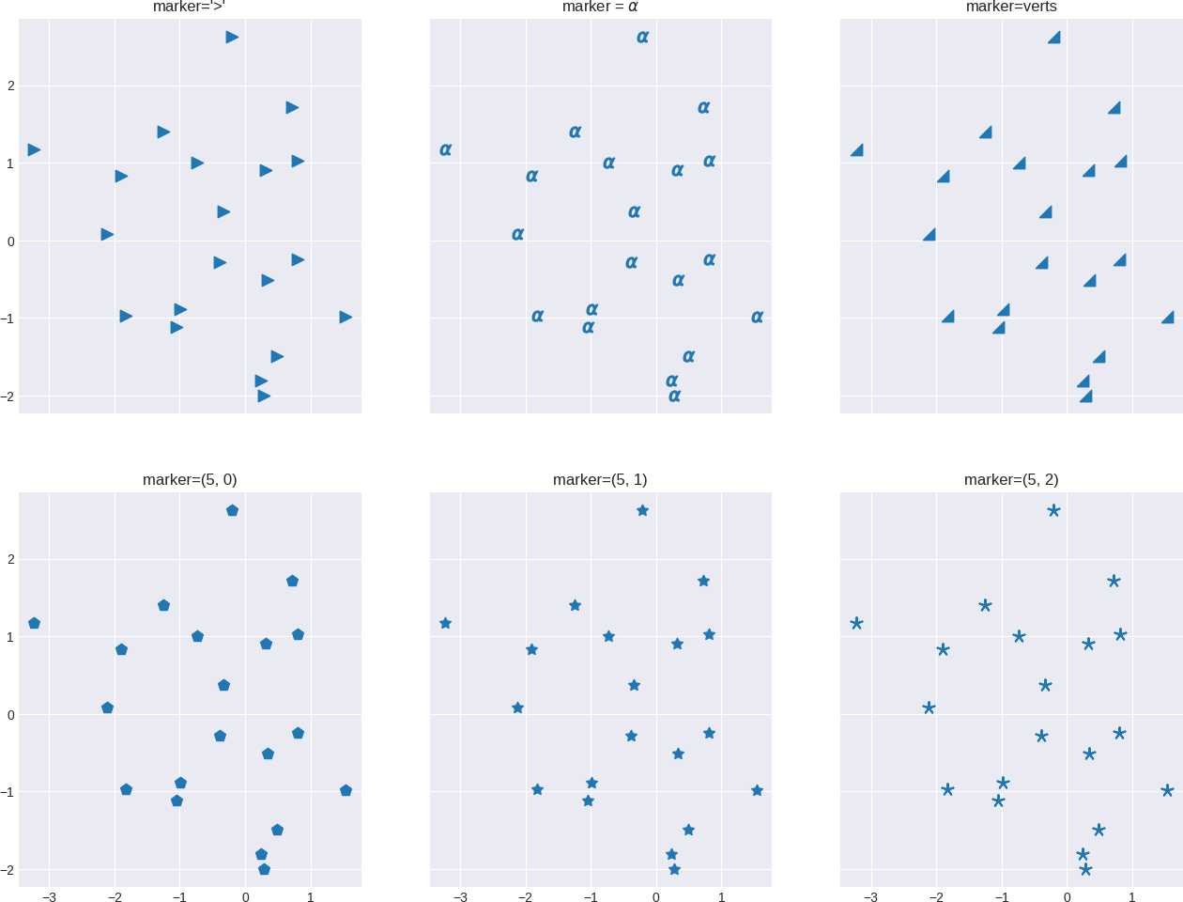

# setting the colors with matplotlib plt.style.use('seaborn-darkgrid')

z1 = np.sqrt(x**2 + y**2) fig, ax = plt.subplots()

pos = ax.scatter(x, y, c=z1, cmap='cool', marker='3')

fig.colorbar(pos);

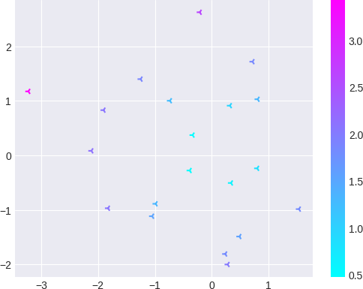 <ipython-input-51-3dd43bf91bb6>:2: MatplotlibDeprecationWarning: The seaborn styles shipped by Matplotlib are deprecated since 3.6, plt.style.use('seaborn-darkgrid')

x = np.random.randn(100) y = np.random.randn(100)

z1 = np.sqrt(x**2 + y**2)

z2 = np.random.randint(10, 200, size=len(x))

fig, ax = plt.subplots()

# pos = ax.scatter(x, y, c=z1, s=z2, alpha = 0.55, cmap='viridis') pos = ax.scatter(x, y, c = z1, s = z2, alpha = 0.55, cmap='RdPu_r') fig.colorbar(pos);

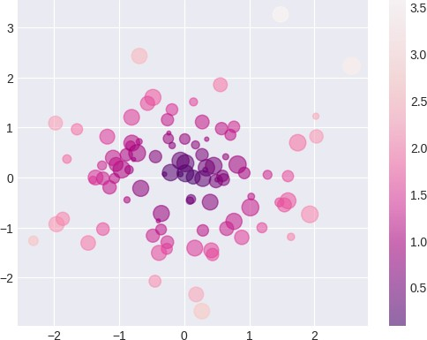

x = np.linspace(0, 10, 30) y = np.sin(x)

plt.plot(x, y, 'o-', color='violet');



# Box plots

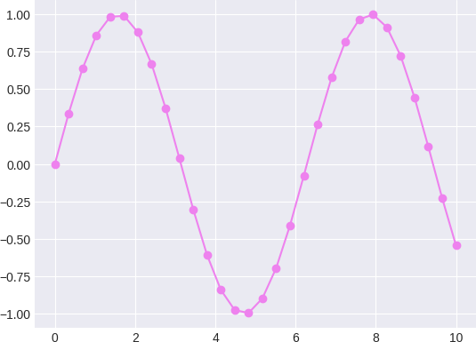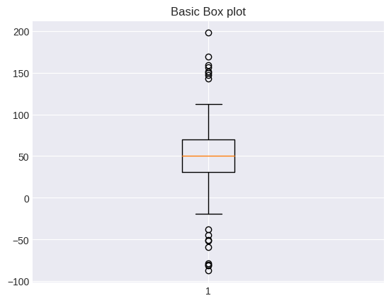

# Generating the data

spread = np.random.rand(50) * 100 center = np.ones(25) * 50

flier_high = np.random.rand(10) * 100 + 100 flier_low = np.random.rand(10) * -100

data = np.concatenate((spread, center, flier_high, flier_low))

# Visualization of the data using box plot (basic) fig, ax = plt.subplots()

ax.boxplot(data)

ax.set_title("Basic Box plot")

Text(0.5, 1.0, 'Basic Box plot')

# Notched boxplot without outliers

###  LABSHEET 7

import pandas as pd

 Code Text

df = pd.read_csv('train.csv') df

|  |  |  |  |  |  |  |  |  |  |  |  |  |  |
| --- | --- | --- | --- | --- | --- | --- | --- | --- | --- | --- | --- | --- | --- |
| **PassengerId** | | **Survived** | | **Pclass** | **Name** | **Sex** | **Age** | **SibSp** | **Parch** | **Ticket** | **Fare** | **Cabin** | **Embarked** |
| 0 1 | | 0 | | 3 | Braund, Mr. Owen Harris | male | 22.0 | 1 | 0 | A/5 21171 | 7.2500 | NaN | S |
| 1 | 2 | 1 | | 1 | Cumings, Mrs. John Bradley (Florence Briggs Th... | female | 38.0 | 1 | 0 | PC 17599 | 71.2833 | C85 | C |
| 2 | 3 | 1 | | 3 | Heikkinen, Miss. Laina | female | 26.0 | 0 | 0 | STON/O2. 3101282 | 7.9250 | NaN | S |
| 3 | 4 | 1 | | 1 | Futrelle, Mrs. Jacques Heath (Lily  May Peel) | female | 35.0 | 1 | 0 | 113803 | 53.1000 | C123 | S |
| 4 | 5 | 0 | | 3 | Allen, Mr. William Henry | male | 35.0 | 0 | 0 | 373450 | 8.0500 | NaN | S |
| ... | ... | ... | | ... | ... | ... | ... | ... | ... | ... | ... | ... | ... |
| 886 | 887 | 0 | | 2 | Montvila, Rev. Juozas | male | 27.0 | 0 | 0 | 211536 | 13.0000 | NaN | S |
| 887 | 888 | 1 | | 1 | Graham, Miss. Margaret Edith | female | 19.0 | 0 | 0 | 112053 | 30.0000 | B42 | S |
| 888 | 889 | 0 | | 3 | Johnston, Miss. Catherine Helen | female | NaN | 1 | 2 | W./C. 6607 | 23.4500 | NaN | S |
|  |  | |  |  | "Carrie" |  |  |  |  |  |  |  |  |
| 889 | 890 | | 1 | 1 | Behr, Mr. Karl Howell | male | 26.0 | 0 | 0 | 111369 | 30.0000 | C148 | C |
| df.dtypes |  | |  | | | | | | | | | | |
| PassengerId | int64 | |
| Survived | int64 | |
| Pclass | int64 | |
| Name | object | |
| Sex | object | |
| Age | float64 | |
| SibSp | int64 | |
| Parch | int64 | |
| Ticket | object | |
| Fare | float64 | |
| Cabin | object | |
| Embarked | object | |
| dtype: object |  | |

|  |  |  |  |  |  |  |  |
| --- | --- | --- | --- | --- | --- | --- | --- |
| df.describe() | **PassengerId** | **Survived** | **Pclass** | **Age** | **SibSp** | **Parch** | **Fare** |
| count | 891.000000 | 891.000000 | 891.000000 | 714.000000 | 891.000000 | 891.000000 | 891.000000 |
| mean | 446.000000 | 0.383838 | 2.308642 | 29.699118 | 0.523008 | 0.381594 | 32.204208 |
| std | 257.353842 | 0.486592 | 0.836071 | 14.526497 | 1.102743 | 0.806057 | 49.693429 |
| min | 1.000000 | 0.000000 | 1.000000 | 0.420000 | 0.000000 | 0.000000 | 0.000000 |
| 25% | 223.500000 | 0.000000 | 2.000000 | 20.125000 | 0.000000 | 0.000000 | 7.910400 |
| 50% | 446.000000 | 0.000000 | 3.000000 | 28.000000 | 0.000000 | 0.000000 | 14.454200 |
| 75% | 668.500000 | 1.000000 | 3.000000 | 38.000000 | 1.000000 | 0.000000 | 31.000000 |
| max | 891.000000 | 1.000000 | 3.000000 | 80.000000 | 8.000000 | 6.000000 | 512.329200 |

df.isna().sum()



|  |  |
| --- | --- |
| PassengerId | 0 |
| Survived | 0 |
| Pclass | 0 |
| Name | 0 |
| Sex | 0 |
| Age | 177 |
| SibSp | 0 |
| Parch | 0 |
| Ticket | 0 |
| Fare | 0 |
| Cabin | 687 |
| Embarked | 2 |
| dtype: int64 |  |

age_mean_value=df['Age'].mean()

df['Age']=df['Age'].fillna(age_mean_value)

df.drop("Cabin",axis=1,inplace=True)

|  |  |  |  |  |  |  |  |  |  |  |  |
| --- | --- | --- | --- | --- | --- | --- | --- | --- | --- | --- | --- |
| df.head()  **PassengerId** | | **Survived** | **Pclass** | **Name** | **Sex** | **Age** | **SibSp** | **Parch** | **Ticket** | **Fare** | **Embarked** |
| 0 1 | | 0 | 3 | Braund, Mr. Owen Harris | male | 22.0 | 1 | 0 | A/5 21171 | 7.2500 | S |
| 1 | 2 | 1 | 1 | Cumings, Mrs. John Bradley (Florence  Briggs Th... | female | 38.0 | 1 | 0 | PC 17599 | 71.2833 | C |
| 2 | 3 | 1 | 3 | Heikkinen, Miss. Laina | female | 26.0 | 0 | 0 | STON/O2. 3101282 | 7.9250 | S |
| 3 | 4 | 1 | 1 | Futrelle, Mrs. Jacques Heath (Lily May  Peel) | female | 35.0 | 1 | 0 | 113803 | 53.1000 | S |
| filtered_age = df[df.Age>40] filtered_age | | | | | | | | | | | |



|  |  |  |  |  |  |  |  |  |  |  |  |
| --- | --- | --- | --- | --- | --- | --- | --- | --- | --- | --- | --- |
|  | **PassengerId** | **Survived** | **Pclass** | **Name** | **Sex** | **Age** | **SibSp** | **Parch** | **Ticket** | **Fare** | **Embarked** |
| 6 | 7 | 0 | 1 | McCarthy, Mr. Timothy J | male | 54.0 | 0 | 0 | 17463 | 51.8625 | S |
| 11 | 12 | 1 | 1 | Bonnell, Miss. Elizabeth | female | 58.0 | 0 | 0 | 113783 | 26.5500 | S |
| 15 | 16 | 1 | 2 | Hewlett, Mrs. (Mary D Kingcome) | female | 55.0 | 0 | 0 | 248706 | 16.0000 | S |
| 33 | 34 | 0 | 2 | Wheadon, Mr. Edward H | male | 66.0 | 0 | 0 | C.A. | 10.5000 | S |
|  |  |  |  |  |  |  |  |  | 24579 |  |  |
| 35 | 36 | 0 | 1 | Holverson, Mr. Alexander Oskar | male | 42.0 | 1 | 0 | 113789 | 52.0000 | S |
| ... | ... | ... | ... | ... | ... | ... | ... | ... | ... | ... | ... |
| 862 | 863 | 1 | 1 | Swift, Mrs. Frederick Joel (Margaret Welles  Ba... | female | 48.0 | 0 | 0 | 17466 | 25.9292 | S |
| 865 | 866 | 1 | 2 | Bystrom, Mrs. (Karolina) | female | 42.0 | 0 | 0 | 236852 | 13.0000 | S |
| 871 | 872 | 1 | 1 | Beckwith, Mrs. Richard Leonard (Sallie  Monypeny) | female | 47.0 | 1 | 1 | 11751 | 52.5542 | S |
| 873 | 874 | 0 | 3 | Vander Cruyssen, Mr. Victor | male | 47.0 | 0 | 0 | 345765 | 9.0000 | S |
| 879 | 880 | 1 | 1 | Potter Mrs Thomas Jr (Lily Alexenia Wilson) | female | 56 0 | 0 | 1 | 11767 | 83 1583 | C |

# let's sort the column Name in ascending order

sorted_passengers = df.sort_values('Name',ascending=True,kind ='heapsort')

sorted_passengers.head(10)



|  |  |  |  |  |  |  |  |  |  |  |  |
| --- | --- | --- | --- | --- | --- | --- | --- | --- | --- | --- | --- |
|  | **PassengerId** | **Survived** | **Pclass** | **Name** | **Sex** | **Age** | **SibSp** | **Parch** | **Ticket** | **Fare** | **Embarked** |
| 845 | 846 | 0 | 3 | Abbing, Mr. Anthony | male | 42.0 | 0 | 0 | C.A. 5547 | 7.5500 | S |
| 746 | 747 | 0 | 3 | Abbott, Mr. Rossmore Edward | male | 16.0 | 1 | 1 | C.A. 2673 | 20.2500 | S |
| 279 | 280 | 1 | 3 | Abbott, Mrs. Stanton (Rosa Hunt) | female | 35.0 | 1 | 1 | C.A. 2673 | 20.2500 | S |
| 308 | 309 | 0 | 2 | Abelson, Mr. Samuel | male | 30.0 | 1 | 0 | P/PP 3381 | 24.0000 | C |
| 874 | 875 | 1 | 2 | Abelson, Mrs. Samuel (Hannah Wizosky) | female | 28.0 | 1 | 0 | P/PP 3381 | 24.0000 | C |
| 365 | 366 | 0 | 3 | Adahl, Mr. Mauritz Nils Martin | male | 30.0 | 0 | 0 | C 7076 | 7.2500 | S |
| 401 | 402 | 0 | 3 | Adams, Mr. John | male | 26.0 | 0 | 0 | 341826 | 8.0500 | S |
| 40 | 41 | 0 | 3 | Ahlin, Mrs. Johan (Johanna Persdotter Larsson) | female | 40.0 | 1 | 0 | 7546 | 9.4750 | S |
| 855 | 856 | 1 | 3 | Aks, Mrs. Sam (Leah Rosen) | female | 18.0 | 0 | 1 | 392091 | 9.3500 | S |
| 207 | 208 | 1 | 3 | Albimona, Mr. Nassef Cassem | male | 26.0 | 0 | 0 | 2699 | 18.7875 | C |

merged_df = pd.merge(df.head(2),df.tail(2),how='outer',indicator=True) merged_df

PassengerId Survived Pclass Name Sex Age SibSp Parch Ticket Fare Embarked _merge

|  |  |  |  |  |  |  |  |  |  |  |  |  |
| --- | --- | --- | --- | --- | --- | --- | --- | --- | --- | --- | --- | --- |
| 0 | 1 | 0 | 3 | Braund, Mr. Owen Harris | male | 22.0 | 1 | 0 | A/5 21171 | 7.2500 | S | left_only |
| 1 | 2 | 1 | 1 | Cumings, Mrs. John Bradley (Florence  Briggs Th... | female | 38.0 | 1 | 0 | PC 17599 | 71.2833 | C | left_only |
| 2 | 890 | 1 | 1 | Behr, Mr. Karl Howell | male | 26.0 | 0 | 0 | 111369 | 30.0000 | C | right_only |

group_df = df.groupby('Name')

group_df

<pandas.core.groupby.generic.DataFrameGroupBy object at 0x111f7ad50>

###  LABSHEET 8

import pandas as pd

import numpy as np

import matplotlib.pyplot as plt

# Sample dataframe with multiple columns data = pd.DataFrame({

"x": np.random.randn(100),

"y": np.random.randn(100),

"value": np.random.randn(100)

})

# Define the colormap and alpha values cmap = "viridis"

alpha = 1

# Create the scatterplot

plt.figure(figsize=(6, 6))

plt.scatter(data["x"], data["y"], c=data["value"], cmap=cmap, alpha=alpha) # Customize the plot (optional)

plt.xlabel("X-axis") plt.ylabel("Y-axis")

plt.title("Scatterplot with Colormap") plt.colorbar(label="value")

# Show the plot plt.show()

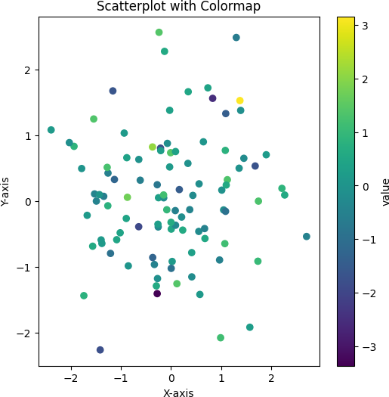

import pandas as pd import numpy as np

print(np.random.randn(100))

 [ 7.25060198e-01 2.53900412e+00 1.26528031e+00 1.84136990e+00

-2.60848832e+00 -5.59983281e-01 4.35035456e-01 -7.00367135e-02 1.96931749e+00 1.04382097e+00 -5.23481680e-01 4.38611173e-01

-6.03314609e-02 -1.62331938e+00 -1.75368806e-01 -1.45327854e-01 7.11162067e-01 -1.24752326e+00 1.10879435e+00 6.15797150e-01

3.22382085e-02 -4.94204444e-01 -1.56553377e+00 1.86476127e+00

-1.53372917e+00 6.21845005e-01 1.08857491e+00 -1.69076421e+00

-3.80722950e+00 4.70410313e-01 8.77562643e-01 -8.95285501e-01 9.83561836e-01 9.32718991e-01 -6.78531171e-01 9.14953408e-05

-2.21344622e+00 -6.15124358e-02 -9.18144802e-02 7.84013469e-01 9.64181023e-01 -1.75737978e+00 1.19471319e+00 -1.02246958e-01

7.73172607e-01 1.02398382e+00 1.47867589e-01 -2.44199793e+00

-8.49499655e-01 1.88210306e-01 -2.61106287e-01 -9.53558247e-01

-8.54821744e-01 -3.80648950e-01 -5.87306646e-01 5.54602769e-01 1.40580004e+00 1.08580790e+00 -8.33862936e-01 7.08280769e-01

-1.43281505e+00 -1.93642975e-01 6.86796860e-01 5.50748349e-01

7.79495185e-01 -2.71795003e-01 -1.16407843e+00 1.38373041e+00

-2.90569948e-01 1.27385062e+00 -4.24752220e-01 5.69263764e-01

-1.45006382e+00 8.39335515e-01 -9.49539071e-01 -2.04611107e+00 1.00680640e+00 2.59974257e-01 -1.29858485e+00 9.67979863e-01

-9.72496062e-01 -1.72551385e+00 -5.42038103e-01 4.26256470e-01

6.57253328e-01 -1.75193447e+00 -1.22202143e+00 -6.31901884e-01

-9.24312354e-01 1.76235295e+00 -6.83714121e-01 5.19175365e-01

-3.18749238e-01 -1.69096151e-01 -4.49121798e-01 3.98598713e-01 8.80300195e-01 -6.39043290e-02 -4.47122464e-01 -1.65126924e-01]

Start coding or ge nerate with AI.

Double-click (or enter) to edit

### LABSHEET 9

# Program to plot 2-D Heat map

# using matplotlib.pyplot.imshow() method import numpy as np

import matplotlib.pyplot as plt

data = np.random.random(( 13 , 16 )) plt.imshow( data,cmap="magma" )

plt.title( "2-D Heat Map" ) plt.colorbar()

plt.show()

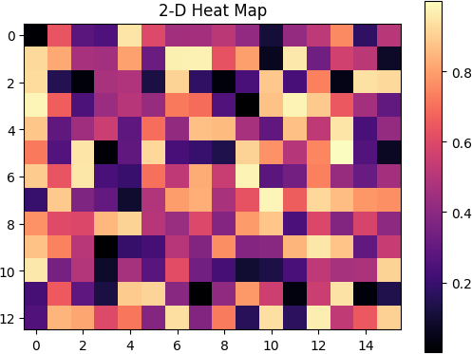

# Program to plot 2-D Heat map

# using matplotlib.pyplot.imshow() method import numpy as np

import matplotlib.pyplot as plt

data = np.random.random((12, 12)) plt.imshow(data, cmap='autumn')

plt.title("Heatmap with different color") plt.show()

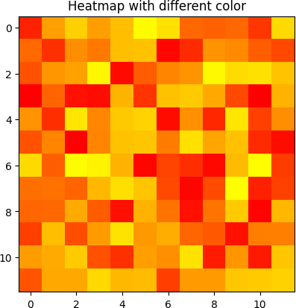

# importing the modules import numpy as np

import seaborn as sns

import matplotlib.pyplot as plt

# generating 2-D 10x10 matrix of random numbers # from 1 to 100

data = np.random.randint(low=14,

high=100,

size=(10, 10))

# plotting the heatmap

hm = sns.heatmap(data=data,annot=True) # displaying the plotted heatmap

plt.show()

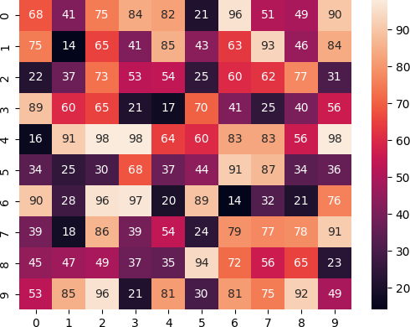

All the IPython Notebooks in **[Python Seaborn Module](https://github.com/milaan9/12_Python_Seaborn_Module)** lecture series by **[Dr. Milaan Parmar](https://www.linkedin.com/in/milaanparmar/)** are available @ **[GitHub](https://github.com/milaan9)**

#  LABSHEET 10



[Open in Colab](https://colab.research.google.com/github/milaan9/12_Python_Seaborn_Module/blob/main/004_Seaborn_Color_Palettes.ipynb)

 Seaborn Color Palettes

Color is an utmost important aspect of figure styling because it reveals pattern in the data if used effectively; or hide those patterns if used poorly. Even professionals often assume usage of color to portray data as a solved problem. They just pick a palette from a drop-down menu

(probably either a grayscale ramp or a rainbow), set start and end points & finally press apply. But it isn't that simple and thus many visualizations fail to represent the underlying data as appropriately as they could.

Primary objective with choice of color is to illuminate datapoints that are concealed in huge datasets. Quoting Robert Simmon:

Although the basics are straightforward, a number of issue complicate color choices in visualization. Among them: The relationship between the light we see and the colors we perceive is extremely complicated. There are multiple types of data, each suited to a different color scheme. A significant number of people

(mostly men), are color blind. Arbitrary color choices can be confusing for viewers unfamiliar with a data set. Light colors on a dark field are perceived differently

than dark colors on a bright field, which can complicate some visualization tasks, such as target detection.

One of the most fundamental and important aspects of color selection is the mapping of numbers to colors. This mapping allows us to pseudocolor an image or object based on varying numerical data. By far, the most common color map used in scientific visualization is the rainbow color map. Research paper on **[Diverging Color Maps for Scientific Visualization](https://cfwebprod.sandia.gov/cfdocs/CompResearch/docs/ColorMapsExpanded.pdf)** by

Kenneth Moreland very well deals with the extended color concepts, if the topic interests you for further analysis.

With all that been said, let us now focus on what Seaborn has to offer BUT before doing that let me once again remind you that Seaborn runs on top of Matplotlib so any color that is supported by **[Matplotlib](https://matplotlib.org/users/colors.html)** will be supported by Seaborn as well. So at first, let us understand what Matplotlib has to offer:

an RGB or RGBA tuple of float values in [0, 1] (e.g., (0.1, 0.2, 0.5) or (0.1, 0.2, 0.5, 0.3)) a hex RGB or RGBA string (e.g., '#0F0F0F' or '#0F0F0F0F')

a string representation of a float value in [0, 1] inclusive for gray level (e.g., '0.5') one of {'b', 'g', 'r', 'c', 'm', 'y', 'k', 'w'}

a X11/CSS4 color name

a name from the xkcd color survey prefixed with 'xkcd:' (e.g., 'xkcd:sky blue') one of {'C0', 'C1', 'C2', 'C3', 'C4', 'C5', 'C6', 'C7', 'C8', 'C9'}

one of {'tab:blue', 'tab:orange', 'tab:green', 'tab:red', 'tab:purple', 'tab:brown', 'tab:pink',

'tab:gray', 'tab:olive', 'tab:cyan'} which are the **[Tableau](https://onlinehelp.tableau.com/current/pro/desktop/en-us/viewparts_marks_markproperties_color.html)** Colors from the ‘T10’ categorical palette (which is the default color cycle).

Note that all string specifications of color, other than "CN", are NOT case-sensitive. Let us briefly go through a couple of common supported colors here:

RGB/RGBA tuples are 4-tuples where the respective tuple components represent Red,

Green, Blue, and Alpha (opacity) values for a color. Each value is a floating point number between 0.0 and 1.0. For example, the tuple (1, 0, 0, 1) represents an opaque red, while (0,

1, 0, 0.5) represents a half transparent green.

This is actually another way of representing RGBA codes and common Color Conversion Calculators can be used to translate values. Here is a **[Hex to RGBA](http://hex2rgba.devoth.com/)** and **[RGB to Hex](https://www.w3schools.com/colors/colors_converter.asp)** Color converter for your future assistance.

Dictionary of values from {'C0', 'C1', 'C2', 'C3', 'C4', 'C5', 'C6', 'C7', 'C8', 'C9'} represent **[Color](https://books.google.co.in/books?id=CsjSBwAAQBAJ&pg=PA128&lpg=PA128&dq=What%2Bare%2B%7B%27C0%27%2C%2B%27C1%27%2C%2B%27C2%27%2C%2B%27C3%27%2C%2B%27C4%27%2C%2B%27C5%27%2C%2B%27C6%27%2C%2B%27C7%27%2C%2B%27C8%27%2C%2B%27C9%27%7D%2Bcolors%3F&source=bl&ots=yk_q-tl53W&sig=Xg5F2P_Evs-YnUNr0wpaiZT7uUU&hl=en&sa=X&ved=0ahUKEwipy_WagonaAhUML48KHZu6Dq4Q6AEIPTAC%23v%3Donepage&q=What%20are%20%7B%27C0%27%2C%20%27C1%27%2C%20%27C2%27%2C%20%27C3%27%2C%20%27C4%27%2C%20%27C5%27%2C%20%27C6%27%2C%20%27C7%27%2C%20%27C8%27%2C%20%27C9%27%7D%20colors%3F&f=false) [Quantization](https://books.google.co.in/books?id=CsjSBwAAQBAJ&pg=PA128&lpg=PA128&dq=What%2Bare%2B%7B%27C0%27%2C%2B%27C1%27%2C%2B%27C2%27%2C%2B%27C3%27%2C%2B%27C4%27%2C%2B%27C5%27%2C%2B%27C6%27%2C%2B%27C7%27%2C%2B%27C8%27%2C%2B%27C9%27%7D%2Bcolors%3F&source=bl&ots=yk_q-tl53W&sig=Xg5F2P_Evs-YnUNr0wpaiZT7uUU&hl=en&sa=X&ved=0ahUKEwipy_WagonaAhUML48KHZu6Dq4Q6AEIPTAC%23v%3Donepage&q=What%20are%20%7B%27C0%27%2C%20%27C1%27%2C%20%27C2%27%2C%20%27C3%27%2C%20%27C4%27%2C%20%27C5%27%2C%20%27C6%27%2C%20%27C7%27%2C%20%27C8%27%2C%20%27C9%27%7D%20colors%3F&f=false)**. I have attached a link in the provided notebook that shall guide you to an online book where on Page-29 you could find specifics.

My sole purpose of keeping you posted of Matplotlib background every now and then is only to

ensure that when you get to production-level and try to customize a plot as per your analysis, you should know what is ACTUALLY running in the background. This shall empower you to accordingly tweak parameters here and there. Let us now look into few Seaborn options for colors:

# Importing required Libraries:

import numpy as np import pandas as pd

import matplotlib.pyplot as plt import seaborn as sns

%matplotlib inline

# Setting a figure size for all the plots we shall be drawing in this kernel: sns.set(rc={"figure.figsize": (6, 6)})

 Building color palettes:

current_palette = sns.color_palette() sns.palplot(current_palette)



The most important function for working with discrete color palettes is **color_palette()** . This function provides an interface to many (though not all) of the possible ways you can generate colors in seaborn, and it’s used internally by any function that has a **palette** argument (and in some cases for a **color** argument when multiple colors are needed).

**color_palette()** will accept the name of any seaborn palette or matplotlib colormap (except **jet** , which you should never use). It can also take a list of colors specified in any valid matplotlib format (RGB tuples, hex color codes, or HTML color names). The return value is always a list of RGB tuples.

Finally, calling **color_palette()** with no arguments will return the current default color cycle.

sns.palplot(sns.color_palette("hls", 8))



sns.palplot(sns.color_palette("husl", 8))



Let me explain these Qualitative (or categorical) palettes. These are best when you want to distinguish discrete chunks of data that do not have an inherent ordering. Ideally, when importing Seaborn, the default color cycle is changed to a set of six colors that evoke the standard matplotlib color cycle. But when we have more than 6, say 8 categories in our data to distinguish, then the most common way is using **hls** color space, which is a simple transformation of RGB values.

Then there is also **hls_palette()** function that lets you control the lightness and saturation of colors.

All of it displayed above is just the basic Seaborn aesthetics. Let us now look at xkcd_rgb

dictionary that has 954 colors in it. Let us try to pull a few out of it:

sample_colors = ["windows blue", "amber", "greyish", "faded green", "dusty purple", "pale red", sns.palplot(sns.xkcd_palette(sample_colors))



Other style is **cubehelix** color palette that makes sequential palettes with a linear increase or decrease in brightness and some variation in **[hue](https://en.wikipedia.org/wiki/Hue)**. Actually let us plot this color palette in a

Density contour plot:

# Default Matplotlib Cubehelix version:

sns.palplot(sns.color_palette("cubehelix", 8))



# Default Seaborn Cubehelix version:

sns.palplot(sns.cubehelix_palette(8))



# Density Plot with Seaborn defaults:

x, y = np.random.multivariate_normal([0, 0], [[1, -.5], [-.5, 1]], size=300).T

sample_cmap = sns.cubehelix_palette(light=1, as_cmap=True) sns.kdeplot(x, y, cmap=sample_cmap, shade=True)

 C:\ProgramData\Anaconda3\lib\site-packages\seaborn\_decorators.py:36: FutureWarning: warnings.warn(

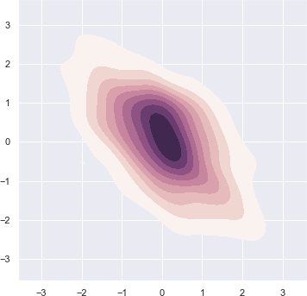<AxesSubplot:>

##  Interactive widget to create a sequential cubehelix palette:

Let us now play with the parameters to have some fun and choose best parameters:

sns.choose_cubehelix_palette(as_cmap=True)



NameError Traceback (most recent call last)

<ipython-input-1-230a1c9055e9> in <cell line: 1>()

----> 1 sns.choose_cubehelix_palette(as_cmap=True) NameError: name 'sns' is not defined

Note that this app only works in this Jupyter Notebook as of now to help choose best parameters for our plot:

sns.palplot(sns.cubehelix_palette(n_colors=8, start=1.7, rot=0.2, dark=0, light=.95, reverse=Tru



start is always between 0 and 3. rot an abbreviation for rotation is kept between -1 and 1. reverse

converses the color ordering and hue refers to plot appearance.

##  Generic Seaborn Plots:

# Loading up built-in dataset:

tips = sns.load_dataset("tips")

# Creating Strip plot for day-wise revenue:

sns.stripplot(x="day", y="total_bill", data=tips, color="g")

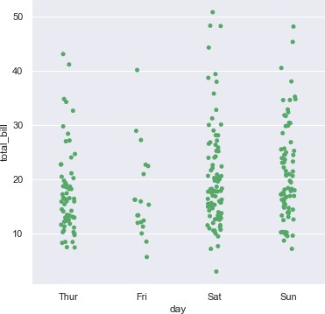 <AxesSubplot:xlabel='day', ylabel='total_bill'>

This does the job for us but let us try to get better results by plotting each day in different color instead of same color. For this, we shall replace **color** parameter with **palette** parameter:

# Set Theme:

sns.set_style('whitegrid')

# Creating Strip plot for day-wise revenue:

sns.swarmplot(x="day", y="total_bill", data=tips, palette="viridis")

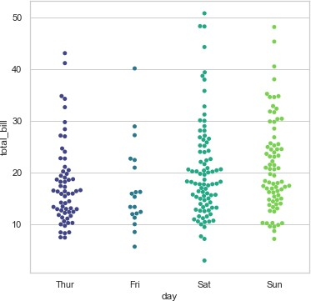<AxesSubplot:xlabel='day', ylabel='total_bill'>

Similarly, let us plot one more and for a change, this time we shall plot a Violin plot:

iris = sns.load_dataset("iris")

sns.boxplot(x="species", y="petal_length", data=iris, palette="cividis")

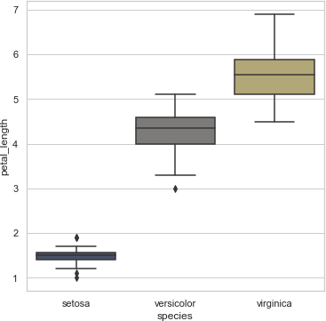 <AxesSubplot:xlabel='species', ylabel='petal_length'>

There are multiple such palette available for us to play around with like magma, warm grey,

gunmetal, dusky blue, cool blue, deep teal, viridian, twilight blue and many more. For customized

color brewing, we may also use color brewer that also offers interesting color palettes for working with Qualitative data. The cool thing about it is that you can use the an interactive Ipython widget function to make the selection of the palette. For this, you only need to use **choose_colorbrewer_palette()** .

There are multiple such palette available for us to play around with like magma, warm grey,

gunmetal, dusky blue, cool blue, deep teal, viridian, twilight blue and many more. For customized color brewing, we may also use color brewer that also offers interesting color palettes for working with Qualitative data. A nice feature of the **[Color Brewer website](http://colorbrewer2.org/#type%3Dsequential%26scheme%3DBuGn%26n%3D3)** is that it provides some guidance on which palettes are color blind safe.

The cool thing about it is that you can use the an interactive Ipython widget function to make the selection of the palette. For this, you only need to use **choose_colorbrewer_palette()** . To access this on your web browser, please access **[ColorBrewer](http://colorbrewer2.org/#type%3Dsequential%26scheme%3DBuGn%26n%3D3)** link provided in the notebook.

I also found a nice representation of Color Schemes in Seaborn, that I found somewhere on web, so thought of sharing it in your Resource bucket to check out if you wish to. Let's have a look at it

LABSHEET 11

#Installation

#pip install seaborn

#####  Seaborn2

Figure

### Figure

It refers to the whole figure that you see. It is possible to have multiple sub-plots (Axes) in the same figure.

### Axes

An Axes refers to the actual plot in the figure. A figure can have multiple Axes but a given Axes can be part of only one figure.

### Axis

An Axis refers to an actual axis (x-axis/y-axis) in a specific plot.

### Four sub-plots (Axes) in a single figure.

Figure2

### Seaborn

Seaborn - can create complicated plot types from Pandas data with relatively simple commands Plotting in seaborn is either : Axes-level functions OR Figure-level function

### PLOT CATEGORIES IN SEABORN

1. **Relational plots :** This plot is used to understand the relation between two variables.
2. **Categorical plots:** This plot deals with categorical variables and how they can be visualized.
3. **Distribution plots:** This plot is used for examining univariate and bivariate distributions
4. **Matrix plots:** A matrix plot is an array of scatterplots.
5. **Regression plots:** The regression plots in seaborn are primarily intended to add a visual guide that helps to emphasize patterns in a dataset during exploratory data analyses.

Seaborn

#Import necessary Packages import numpy as np

import pandas as pd

import matplotlib.pyplot as plt

from matplotlib.pyplot import figure import seaborn as sns

%matplotlib inline

#Simple Plotting with Seaborn

#Data

dates = ['1981-01-01', '1981-01-02', '1981-01-03', '1981-01-04', '1981-01-05',

'1981-01-06', '1981-01-07', '1981-01-08', '1981-01-09', '1981-01-10' ]

min_temperature = [20.7, 17.9, 18.8, 14.6, 15.8, 15.8, 15.8, 17.4, 21.8, 20.0]

max_temperature = [34.7, 28.9, 31.8, 25.6, 28.8, 21.8, 22.8, 28.4, 30.8, 32.0]

#Plotting

fig,axes = plt.subplots(nrows=1, ncols=1, figsize=(15,10)) axes.plot(dates, min_temperature, label='Min Temperature') axes.plot(dates, max_temperature, label = 'Max Temperature') axes.legend()

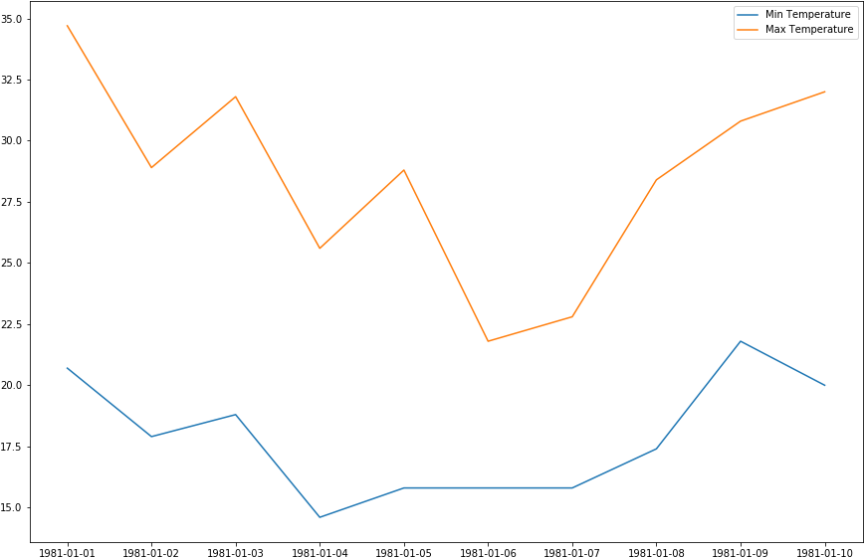 <matplotlib.legend.Legend at 0x1c0d2b24748>

#seaborn style as the default matplotlib style sns.set()

#Simple sine plot

x = np.linspace(0, 10, 1000)

plt.plot(x, np.sin(x), x, np.cos(x));

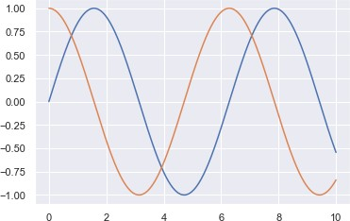

# I. Relational Plots

# Line plot : The line plot is one of the most basic plot in seaborn library.

#This plot is mainly used to visualize the data in form of some time series, i.e. in continuous manner. sns.set(style="dark")

fig, ax = plt.subplots(ncols=2, nrows=1, figsize=(15,10))

#Loading Data with Seaborn

df = sns.load_dataset("tips") print(df.head())

#lineplot

sns.lineplot(x="total_bill", y="tip", hue="size", style="time", data=df,ax=ax[0]).set_title("Line Plot")

#scatterplot

Sct_plt=sns.scatterplot(x="total_bill", y="tip", hue="size", style="time", data=df,ax=ax[1]).set_title("Scatter Plot")

#Saving Plot

Sct_plt.figure.savefig('Scatter_plot1.png') print('Plot Saved')

 total_bill tip sex smoker day time size

1. 16.99 1.01 Female No Sun Dinner 2
2. 10.34 1.66 Male No Sun Dinner 3
3. 21.01 3.50 Male No Sun Dinner 3
4. 23.68 3.31 Male No Sun Dinner 2
5. 24.59 3.61 Female No Sun Dinner 4

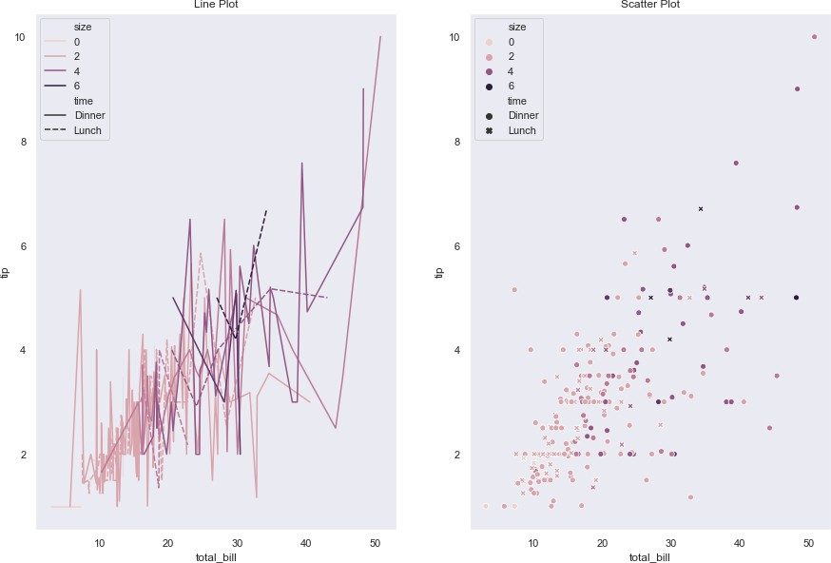Plot Saved

#II. Categorical Plots

#Plots are basically used for visualizing the relationship between variables.

#Variables can be either be completely numerical or a category like a group, class or division.

sns.set_style('darkgrid')

fig, ax =plt.subplots(nrows=5,ncols=2) fig.set_size_inches(18.5, 10.5)

#Data

# 'tips’ dataset contains information about people who probably had food at a restaurant

# whether or not they left a tip for the waiters, their gender, whether they smoke and so on. df = sns.load_dataset('tips')

#barplot - basically used to aggregate the categorical data according to some methods and by default its the mean

sns.barplot(x ='sex', y ='total_bill', data = df,palette ='plasma', estimator = np.std,ax=ax[0,0]).set_title('Bar Plot')

#countplot -Counts the categories and returns a count of their occurrences sns.countplot(x ='sex', data = df,ax=ax[0,1]).set_title('Count Plot')

#boxplot - known as the box and whisker plot.

#It shows the distribution of the quantitative data that represents the comparisons between variables sns.boxplot(x ='day', y ='total_bill', data = df, hue ='smoker',ax=ax[1,0]).set_title('Box Plot')

# Similar to the boxplot except that it provides a higher, more advanced visualization

# Uses the kernel density estimation to give a better description about the data distribution.

sns.violinplot(x ='day', y ='total_bill', data = df, hue ='sex', split = True,ax=ax[1,1]).set_title('Violin Plot')

#Stripplot - scatter plot based on the category

sns.stripplot(x ='day', y ='total_bill', data = df, jitter = True, hue ='smoker', dodge = True,ax=ax[2,0]).set_title('Strip Plot')

#Swarmplot-similar to stripplot except the fact that the points are adjusted so that they do not overlap. sns.swarmplot(x ='day', y ='total_bill', data = df,ax=ax[2,1]).set_title('Swarm Plot')

#Combining the idea of a violin plot and a stripplot to form this plot sns.violinplot(x ='day', y ='total_bill', data = df,ax=ax[3,0])

sns.swarmplot(x ='day', y ='total_bill', data = df, color ='black',ax=ax[3,0]).set_title('Combined Plot')

# Density Plot

sns.kdeplot(df['tip'], df['total_bill'],ax=ax[3,1])

#boxenplot

sns.boxenplot(x="day", y="total_bill",color="b", scale="linear", data=df,ax=ax[4,0])

#Ridgeplot

sns.pointplot(x="day", y="total_bill",color="b", hue="sex", data=df,ax=ax[4,1])

#catplot

#General plot - provides a parameter called 'kind' to choose the kind of plot ,better that writing the plots separately. #The kind parameter can be bar, violin, swarm etc.

sns.catplot(x ='day', y ='total_bill', data = df, kind ='bar')

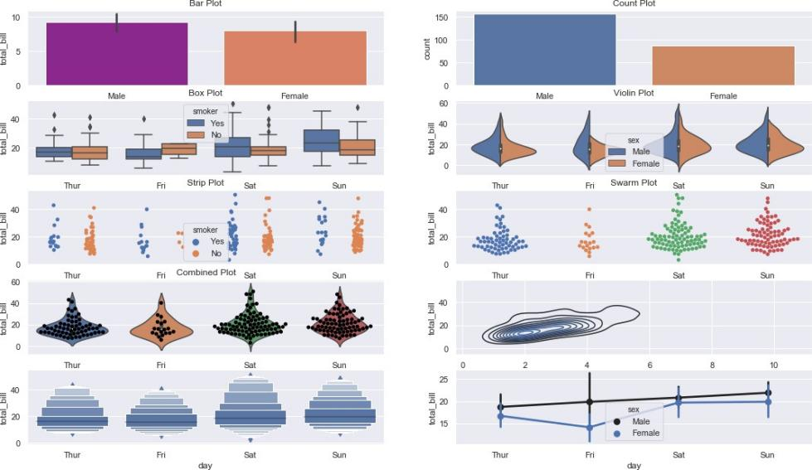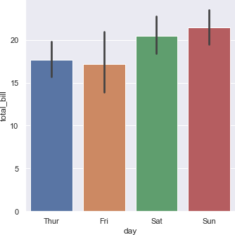<seaborn.axisgrid.FacetGrid at 0x1c0d3615888>

III. **Distribution plots** in seaborn is used for examining univariate and bivariate distributions. 4 main types of distribution plots :

joinplot distplot pairplot rugplot

sns.set_style('whitegrid')

#Data - 'iris'

df = sns.load_dataset('iris') print(df.head())

#Displot- used for univariant set of observations and visualizes it through a histogram #i.e. only one observation and hence we choose one particular column of the dataset.

#KDE is a way to estimate the probability density function (PDF) of the random variable that “underlies” the sample. #KDE is a means of data smoothing.

#bins is used to set the number of bins you want in your plot and it actually depends on your dataset. #color is used to specify the color of the plot

sns.distplot(df['petal_length'], kde = True, color ='red', bins = 30).set_title('Dist Plot')

#Joinplot/jointgrid- draw a plot of two variables with bivariate and univariate graphs. It basically combines two different plots. #Plot a bi-variate distribution along with marginal distributions in the same plot

#Joint Distribution of two variables can be visualised using scatter plot/regplot or kdeplot. #Marginal Distribution of variables can be visualised by histograms and/or kde plot

#KDE shows the density where the points match up the most

#The Axes-level function to use for joint distribution must be passed to JointGrid.plot_joint().

#The Axes-level function to use for marginal distribution must be passed to JointGrid.plot_marginals()

jointgrid = sns.JointGrid(x='petal_length', y='petal_width', data=df) jointgrid.plot_joint(sns.scatterplot)

jointgrid.plot_marginals(sns.distplot)

#jointplot() to plot bi-variate distribution along with marginal distributions. #It uses JointGrid() and JointGrid.plot_joint() in the background.

g=sns.jointplot(x = 'petal_length',y = 'petal_width',data = df,kind = 'hex') g.fig.suptitle('Joint Plot')

#Pairplot- pairwise relation across the entire dataframe

#hue sets up the categorical separation between the entries in the dataset. #palette is used for designing the plots.

g=sns.pairplot(df, hue ="species", palette ='coolwarm') g.fig.suptitle("Pair Plot 1")

g.add_legend()

#PairGrid() - creates Axes for each pair of variables

#PairGrid.map() - draws the plot on each Axes using data corresponding to that pair of variables pairgrid = sns.PairGrid(data=df)

pairgrid = pairgrid.map_offdiag(sns.scatterplot) pairgrid = pairgrid.map_diag(plt.hist)

#Different kind of plots on Upper Triangular Axes, Diagonal Axes and Lower Triangular Axes. pairgrid = sns.PairGrid(data=df)

pairgrid = pairgrid.map_upper(sns.scatterplot) pairgrid = pairgrid.map_diag(plt.hist)

pairgrid = pairgrid.map_lower(sns.kdeplot)

#Avoid Redundancy

g = sns.PairGrid(df, diag_sharey=False, corner=True) g.map_lower(sns.scatterplot)

g.map_diag(sns.kdeplot)

 sepal_length sepal_width petal_length petal_width species 0 5.1 3.5 1.4 0.2 setosa

1 4.9 3.0 1.4 0.2 setosa

2 4.7 3.2 1.3 0.2 setosa

3 4.6 3.1 1.5 0.2 setosa

4 5.0 3.6 1.4 0.2 setosa

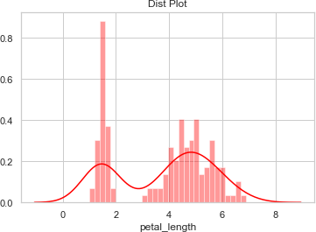<seaborn.axisgrid.PairGrid at 0x1c0d2b15888>

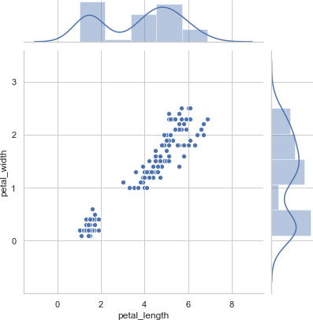

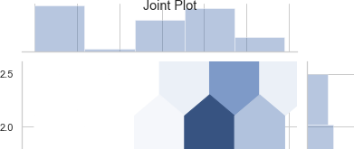

###  LABSHEET 12

###### Load the Pacakges

To get started, open a Colab notebook and load the Pandas, Matplotlib, and Wordcloud packages.

 Code Text

import pandas as pd

import matplotlib.pyplot as plt from wordcloud import WordCloud from wordcloud import STOPWORDS

Mount the drive and read the CSV file from the drive.

Here we are going to use netflix_titles.csv dataset downloaded from kaggle. Since it is text visualization we are going to consider only one column.

from google.colab import drive

drive.mount('/content/drive/')

 Mounted at /content/drive/

df=pd.read_csv('/content/drive/My Drive/Data/netflix_titles.csv', usecols=['cast']) df.head()

**cast**

1. NaN
2. Ama Qamata, Khosi Ngema, Gail Mabalane, Thaban...
3. Sami Bouajila, Tracy Gotoas, Samuel Jouy, Nabi...
4. NaN
5. Mayur More, Jitendra Kumar, Ranjan Raj, Alam K...

Perform Prepeocessing to remove the records containing NaN

ndf=df.dropna() ndf.head()

cast

1. Ama Qamata, Khosi Ngema, Gail Mabalane, Thaban...
2. Sami Bouajila, Tracy Gotoas, Samuel Jouy, Nabi...
3. Mayur More, Jitendra Kumar, Ranjan Raj, Alam K...
4. Kate Siegel, Zach Gilford, Hamish Linklater, H...
5. Vanessa Hudgens, Kimiko Glenn, James Marsden, ...

The wordcloud package requires single string instead of column.

Joining the all text data of the coloumn 'cast' to single string to make text visualization easy

text = " ".join(item for item in ndf['cast']) print(text)

 Ama Qamata, Khosi Ngema, Gail Mabalane, Thabang Molaba, Dillon Windvogel, Natasha Thahane, Arno Greeff, Xolile Tshabalala, Getmore

Sometimes, there will be words in your dataframe that are insignificant and don’t add any insight. We can take these out using the STOPWORDS module which is included in Wordcloud.

stopwords = set(STOPWORDS)

###### Create a basic word cloud

By instantiating WordCloud and then appending generate(text), we can pass in our big list of words and WordCloud will calculate the word frequencies, and determine the sizes, and colours of each of the words shown based on their frequencies within the text.

The other bits of Matplotlib code turn off the axes and ticks to make the word cloud look a bit neater.

wordcloud = WordCloud(background_color="white").generate(text) plt.imshow(wordcloud, interpolation='bilinear')

plt.axis("off")

plt.margins(x=0, y=0) plt.show()



wordcloud = WordCloud(background_color="white", max_words=100,

max_font_size=300, width=800,

height=500,

colormap="magma"

).generate(text)

plt.figure(figsize=(20,20))

plt.imshow(wordcloud, interpolation='bilinear') plt.axis("off")

plt.margins(x=0, y=0)

plt.savefig("cloud.jpg", format="jpg") plt.show()

 

###  LABSHEET 13

A time series is the series of data points listed in time order.

A time series is a sequence of successive equal interval points in time.

A time-series analysis consists of methods for analyzing time series data in order to extract meaningful insights and other useful characteristics of data.

For performing time series analysis download stock_data.csv

import pandas as pd

import numpy as np import matplotlib.pyplot as plt

# reading the dataset using read_csv df = pd.read_csv(r"stock_data.csv")

# displaying the first five rows of dataset df.head()



|  |  |  |  |  |  |  |
| --- | --- | --- | --- | --- | --- | --- |
| **Date** | **Open** | **High** | **Low** | **Close** | **Volume** | **Name** |
| **0** 1/3/2006 | 39.69 | 41.22 | 38.79 | 40.91 | 24232729 | AABA |
| **1** 1/4/2006 | 41.22 | 41.90 | 40.77 | 40.97 | 20553479 | AABA |
| **2** 1/5/2006 | 40.93 | 41.73 | 40.85 | 41.53 | 12829610 | AABA |
| **3** 1/6/2006 | 42.88 | 43.57 | 42.80 | 43.21 | 29422828 | AABA |
| **4** 1/9/2006 | 43.10 | 43.66 | 42.82 | 43.42 | 16268338 | AABA |

We have used the ‘parse_dates’ parameter in the read_csv function to convert the ‘Date’ column to the DatetimeIndex format. By default, Dates are stored in string format which is not the right format for time series data analysis.

Now, removing the unwanted columns from dataframe i.e. ‘Unnamed: 0’. Example 1: Plotting a simple line plot for time series data.

df['Volume'].plot()

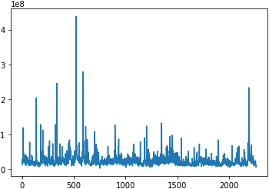 <AxesSubplot:>

Example 2: Now let’s plot all other columns using subplot.

 array([<AxesSubplot:>, <AxesSubplot:>, <AxesSubplot:>, <AxesSubplot:>,

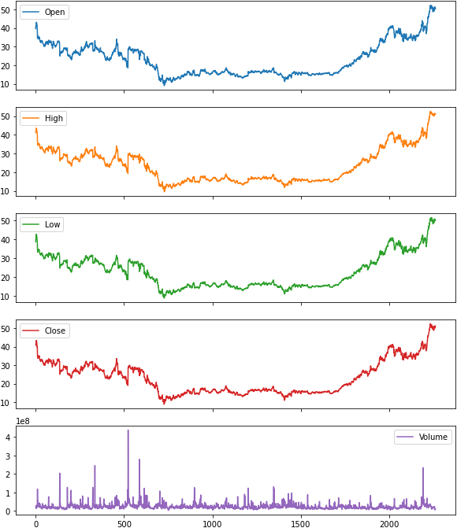<AxesSubplot:>], dtype=object)

Resampling: Resampling is a methodology of economically using a data sample to improve the accuracy and quantify the uncertainty of a population parameter. Resampling for months or weeks and making bar plots is another very simple and widely used method of finding seasonality. Here we are going to make a bar plot of month data for 2016 and 2017.

Example 3:

Differencing: Differencing is used to make the difference in values of a specified interval. By default, it’s one, we can specify different values for plots. It is the most popular method to remove trends in the data.

df.Low.diff(2).plot(figsize=(10, 6))

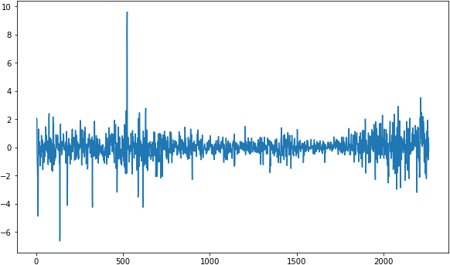 <AxesSubplot:>

df.High.diff(2).plot(figsize=(10, 6))

<AxesSubplot:>

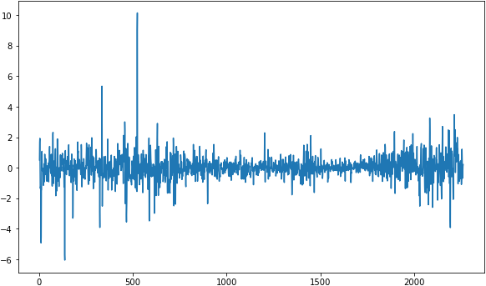

**Plotting the Changes in Data**

We can also plot the changes that occurred in data over time. There are a few ways to plot changes in data.

Shift: The shift function can be used to shift the data before or after the specified time interval. We can specify the time, and it will shift the data by one day by default. That means we will get the previous day’s data. It is helpful to see previous day data and today’s data simultaneously side by side.

df['Change'] = df.Close.div(df.Close.shift())

df['Change'].plot(figsize=(10, 8), fontsize=16)

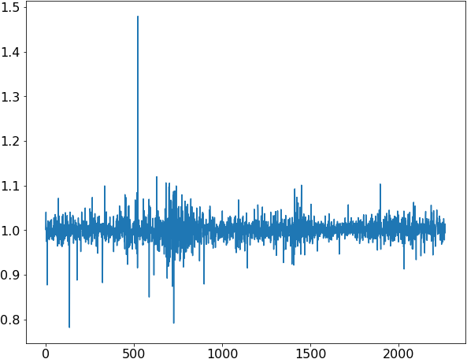 <AxesSubplot:>

.div() function helps to fill up the missing data values. Actually, div() means division.

If we take df. div(6) it will divide each element in df by 6.

We do this to avoid the null or missing values that are created by the ‘shift()’ operation. Double-click (or enter) to edit